Thời gian làm bài: 40 phút (Không kể thời gian giao đề)
-------------------------
Họ tên thí sinh: .................................................................
Số báo danh: ......................................................................
Mã Đề: 040.
Câu 1. Which of the following statements is true?
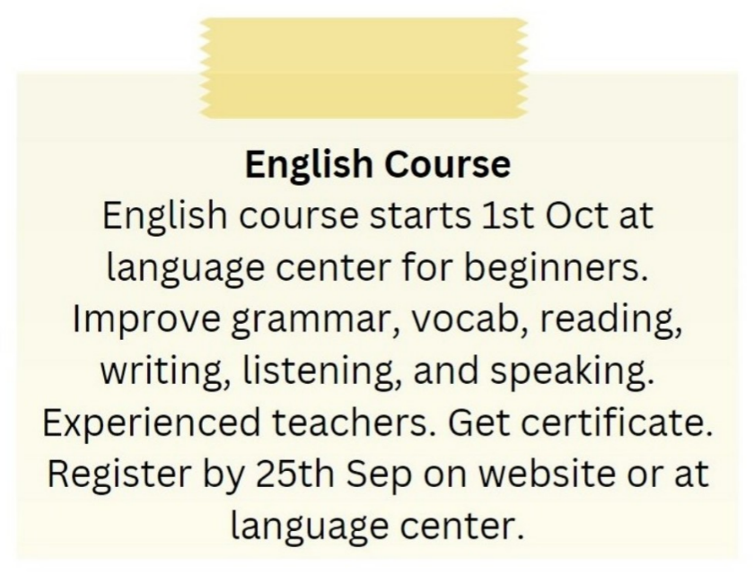
A. The English course is for advanced learners.
B. The English course does not provide a certificate.
C. The English course is taught by experienced teachers.
D. The English course starts on 1st September.
Câu 2. What does it say?
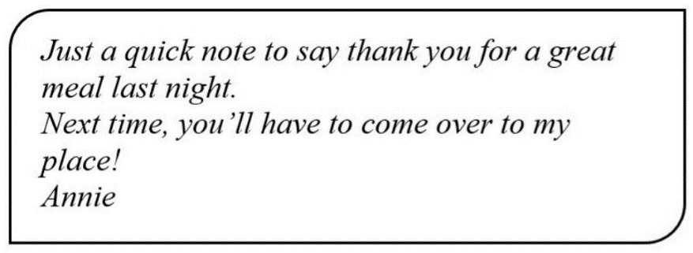
A. Annie cooked a great meal last night. B. Annie went to a restaurant last night.
C. Annie went to her friend’s house last night. D. Annie invited her friend to her house last night.
Câu 3. What does Paul request from Alice in his message?
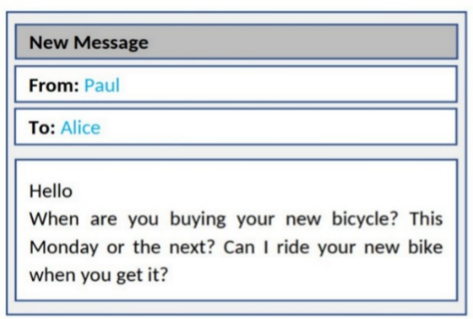
A. To teach him how to ride a bicycle B. To borrow money for a bicycle
C. To go bicycle shopping together D. To try out her new bicycle when she gets it
Câu 4. Look at the signs. Choose the best answer for the question.
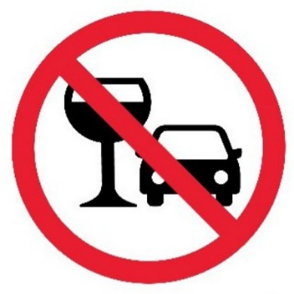
A. You cannot use glasses in the car.
B. You should stop driving if you want to drink water.
C. You are not allowed to drink alcohol before and while driving.
D. You mustn’t drink anything while you are driving.
Câu 5. Look at the signs. Choose the best answer for question.
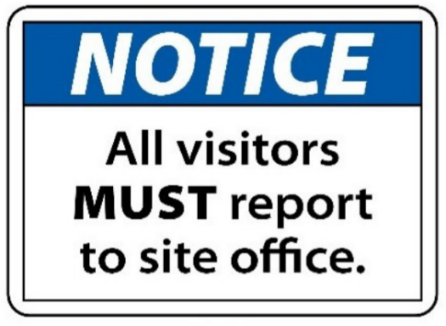
A. Guests are reported to visit the site office.
B. Anyone who visits must go to the site office and check in.
C. The site office is for everyone to make a report.
D. All visitors can enter the place through the site office.
Câu 6. Look at the signs. Choose the best answer for the question.
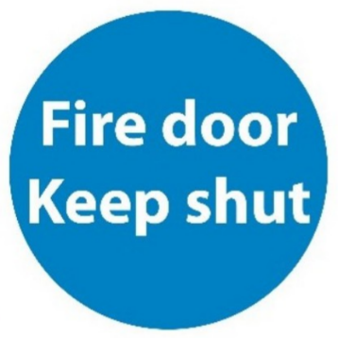
A. This door must remain closed to prevent the spread of fire.
B. You mustn’t put the door on fire.
C. You should keep the door open unless there is a fire.
D. You should only shut the door when it is on fire.
Câu 7. "What activity is the person inviting their friend to do?"
Hey friend! I hope you're having a good day. I wanted to see if you're up for watching a film this weekend. I heard that a new blockbuster just came out and it's supposed to be really good. Let me know if you're free and we can catch it together.
A. Read a book B. Attend a play C. Watch a film D. Go to a museum
Câu 8. Look at the signs. Choose the best answer for the question.
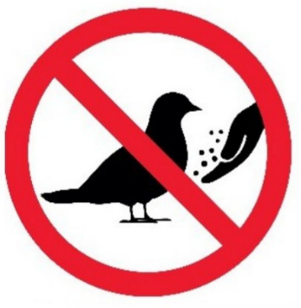
A. No bird can be found here. B. You mustn’t feed the birds.
C. Birds don’t have to be given food. D. You can’t bring any birds here.
Câu 9. What can you see at the circus?
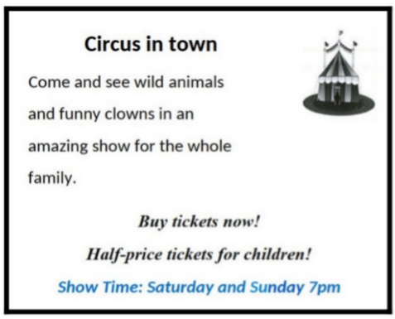
A. Only funny clowns B. Wild animals and funny clowns
C. Only wild animals D. Only acrobats
Câu 10. What is the main reason James cannot attend the concert?
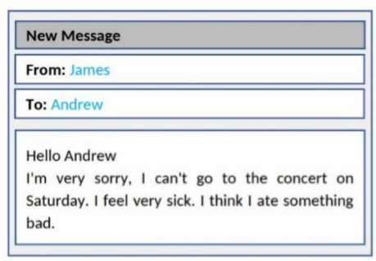
A. He lost his ticket B. He is feeling unwell
C. He doesn't like the music D. He has another commitment
----HẾT---

