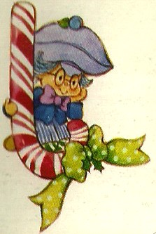
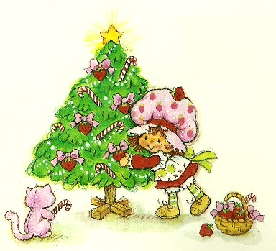
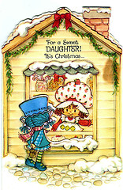
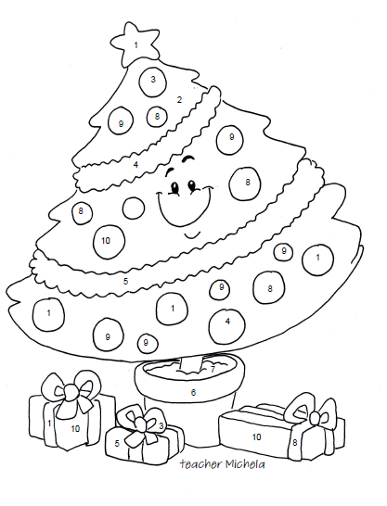
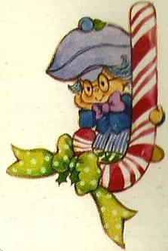
1
Read and colour
- One is yellow.
- Two is green.
- Three is red.
- Four is light blue.
- Five is orange.
- Six violet.
- Seven is brown.
- Eight is purple.
- Nine is pink.
- Ten is blue
Colour the funny Christmas tree
In the picture you can see:

- A star
- A Christmas tree
- Three presents
- Seventeen balls
- A vase
- Two strings of decorations

