**ĐỀ SỐ 46**

**Mark the letter A, B, C, or D on your answer sheet to indicate the word whose underlined part differs from the other three in pronunciation in each of the following questions.**

**Question 1.** A. park B. start C. card D. catch

**Question 2.** A. chaos B. chance C. cheer D. child

Mark the letter A, B, C, or D on your answer sheet to indicate the word that differs from the other three in the position of primary stress in each of the following questions.

Question 3. A. tourist B. sunshine C. weather D. control

Question 4. A. ambitious B. beautiful C. suitable D. different

Mark the letter A, B, C, or D on your answer sheet to indicate the correct answer to each of the following questions.

Question 5. I don’t want much sugar in my coffee. Just ______, please?

A. a few B. any C. few D. a little

Question 6. She didn’t have enough time ______ all the interesting places.

A. visit B. visiting C. visited D. to visit

Question 7. Tony doesn’t work ______ Antony.

A. as hard B. more hard than

C. as hard as D. most hardest

Question 8. If they worked more carefully, they ______ so many mistakes.

A. won’t make B. don’t make C. wouldn’t make D. didn’t make

Question 9. He prefers soccer ______ tennis.

A. from B. than C. to D. or

Question 10. There is ______ apple, ______ banana and ______ cups of tea on the table.

A. an – a – some B. an – a – a C. a – an – some D. some – a – some

**Question 11.** Who will look **______** the baby while we go out?

A. out B. up C. on D. after

Question 12. “It is very kind of you to invite us to your party.” - “______”

A. No, thanks. B. Good idea, thanks.

C. OK. That’s great. D. It’s my pleasure.

Read the following announcement and mark the letter A, B, C, or D on your answer sheet to indicate the correct option that best fits each of the numbered blanks from 13 to 16.

Announcement of Autumn Break

Dear Parents,

Please note that school will be closed (**13**) **______** Monday 23rd October to Sunday 29th October for the Mid Term Autumn (**14**) **______**.

Students should (**15**) **______** to school on Monday 30th October, 2023.

If you have (**16**) **______** questions, please contact us at 0227.222.468.

Best regards.

**Question 13.** A. on B. from C. in D. during

**Question 14.** A. break B. relaxation C. rest D. end

**Question 15.** A. return B. come C. go D. arrive

**Question 16.** A. some B. a C. any D. many

**Question 17.** ***Put the sentences (a-c) in the correct order, then fill in the blank to make a logical text.***

Last weekend, I went to a music festival with my friends. We had a great time, but there was one downside. **______**

a. We danced to our favourite bands and sang along to the music.

b. We had been looking forward to the festival for weeks.

c. Unfortunately, the sound system was terrible, and we couldn't hear the music very well.

A. b-a-c B. a-b-c C. c-b-a D. c-a-b

Question 18. Choose the sentence that can end the text (in Question 17) most appropriately.

A. Despite the sound problems, we still had a lot of fun.

B. I hope the organisers won’t improve the sound system next year.

C. I’m not sure if I’ll go to another music festival again.

D. The festival was held in a beautiful outdoor location.

Read the following passage and mark the letter A, B, C, or D on your answer sheet to indicate the correct word or phrase that best fits each of the numbered blanks from 19 to 24.

More and more people live in large cities these days and this means that it is s becoming difficult (**19**) **______** space and time for themselves. But for many people, personal privacy is very important. In many homes, (**20**) **______** minutes in the bathroom is all the privacy that is available. Teenagers need their own personal space at home (**21**) **______** they can feel relaxed and private. But, of course, not all teenagers are lucky enough to have a room of their own. Where space is narrow, they often (**22**) **______** share a bedroom with a brother or sister. In that case, it's a good idea for them to have a special area or corner of the room to call their own. It's especially important for young people to have somewhere to keep their personal things. There should be enough storage space for them (**23**) **______** shelves, cupboards and boxes. This will (**24**) **______** the teenagers to keep their space tidy if they want to.

**Question 19.** A. finding B. to find C. find D found

**Question 20.** A. any B. a C. a little D. a few

**Question 21.** A. who B. whose C. where D. whom

**Question 22.** A. have to B. should C. may D. can

**Question 23.** A. as B. such as C. so that D. because of

Question 24. A. let B. prevent C. make D. allow

Mark the letter A, B, C or D on your answer sheet to indicate the sentence that is closest in meaning to the original sentence in each of the following questions.

**Question 25.** “Can you pass me the notebook, Janet”? asked Peter.

A. Peter asked if Janet could pass him the notebook.

B. Peter asked if Janet can pass him the notebook.

C.Peter asked if Janet could pass me the notebook.

D. Peter asked if you could pass him the notebook.

**Question 26.** This is the first time I have seen that man.

A. I haven’t never seen that man here before.

B. I have seen that man here before.

C. Ihaven’t seen that man here before.

D. I haven’t saw that man here before.

Mark the letter A, B, C, or D on your answer sheet to indicate the sentence that is made from the given cues in each of the following questions.

**Question 27.** New York / crowded / city / the world.

A. New York is most crowded city in the world.

B. New York is the most crowded city in the world.

C.New York is the crowdedest city in the world.

D. New York is the more crowded city in the world.

**Question 28.** About / use / banana leaves / instead / plastic bags / save energy?

A. What about to use banana leaves instead of plastic bags to save energy?

B. How about using banana leaves instead of plastic bags save energy?

C.What about using banana leaves instead of plastic bags to save energy?

D. How about use banana leaves instead of plastic bags to save energy?

**Read the following sign or notice and mark the letter A, B, C, or D on your answer sheet to indicate the correct answer to each of the following questions.**

**Question 29.** What does the sign say?

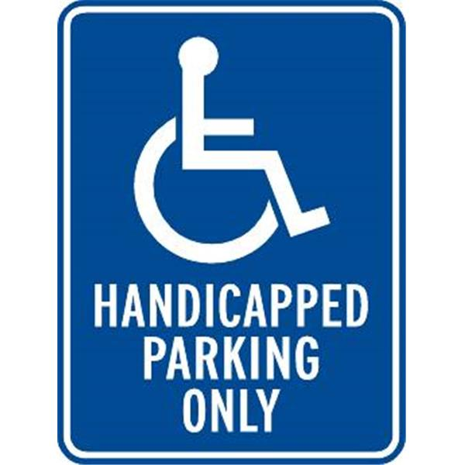

A. Anyone can park here.

B. Only vehicles with a handicap permit can park here.

C.Parking is free in this spot.

D. This spot is reserved for electric vehicles.

**Question 30.** What does the message say?

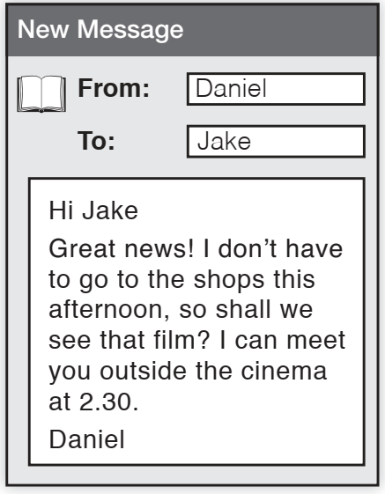

A. Daniel is going to the shops and will meet Jake later.

B. Daniel wants to see a film with Jake and can meet at 2:30.

C. Daniel cannot meet Jake this afternoon.

D. Daniel wants to see the film alone and will not meet Jake.

Read the following passage and mark the letter A, B, C, or D on your answer sheet to indicate the correct answer to each of the following questions from 31 to 36.

The most **obvious** advantage of living green is that it helps reduce environmental pollution. This is done by practising the 3Rs.The first R means choosing products very carefully to reduce waste as much as possible. Reusing involves the repeated use of items. The third R is about separating materials that can be recycled and later used for a new purpose.

There are also economic benefits to living green. Reducing the use of energy and water can help save money on household bills. Furthermore, reusing products and materials is another way to make savings, **it** helps save on production costs since creating new products wastes materials and is expensive. Recycled products also last longer than Í new ones, making them a better and more eco-friendly option.

Lastly, going green offers health benefits. It reduces air pollutants by making the air we breathe cleaner and healthier. This means fewer diseases and doctor's appointments. Another way to improve your health is to purchase organic foods and green products for your household. They don't use **harmful** chemicals that can lead to health issues. In turn, you are also supporting responsible farming methods that protect the environment.

**Question 31.** What is the passage mainly about?

A. The pros of a green lifestyle.

B. Difficulties in adopting a green lifestyle.

C. Trends in green living.

D. Using organic foods and green products for your household.

**Question 32.** The word **“obvious"** in the 1st paragraph is OPPOSITE in meaning to **______**.

A. noticeable B. unclear C. evident D. certain

**Question 33.** According to the text, how can we practise the 3Rs?

A. By reducing waste as much as possible.

B. By reusing and recycling items.

C.By saving money on household bills.

D. By doing both A and B above.

**Question 34.** Which of the following is given in the text as a benefit of living green?

A. political benefit C.cultural benefit

B. health benefit D. industrial benefit

**Question 35.** The word ‘**it**’ in paragraph 2 refers to **______**.

A. creating new products B. reusing products

C.making savings D. purchasing organic foods

**Question 36.** The word **‘harmful’** in the last paragraph is CLOSEST in meaning to **______**.

A. economical B. toxic C.pure D. beneficial

Four phrases/ sentences have been removed from the text below. For each question, mark the letter A, B, C, or D on your answer sheet to indicate the correct option that best fits each of the numbered blanks from 37 to 40.

Cultural differences occur wherever you go abroad. When visiting another country, you should be aware of those differences and respect them. (**37**) **______**.

Every traveller to a foreign country feels awkward at some point. (**38**) **______**. Your best defence is a sense of humour. If you can laugh off eating with the wrong hand in s India, locals will be more accepting of you.

(**39**) **______** is important too because locals will judge you by what you wear. In some Middle Eastern countries, exposing your flesh is forbidden, especially if you are a woman. So, leave your torn jeans at home.

Also, be cautious about expressing emotions. (**40**) **______** just makes you look silly.

In some countries, it is unwise to kiss in public.

A. Here are some tips on how to fit in

B. Wearing proper clothes

C. How you act may make locals laugh

D. Getting angry in Southeast Asia

**Question 37.** __________ **Question 38.** __________

**Question 39.** __________ **Question 40.** __________