School: ……………………………………….. | Date:……………………………………..
Class: ……………………………..................... | Period: 45

UNIT 3: ARTS AND MUSIC
Grammar 3e (page 53)

1. Objectives
By the end of this lesson, students will be able to…
1.1. Language knowledge/ skills
- learn new grammar point: Definite/Indefinite articles – Zero article.
- practise doing grammar exercises.
- make sentences using Definite/Indefinite articles – Zero article.
1.2. Competences
- improve Ss’ analytical, collaboration and critical thinking skills.
1.3. Attributes
- build their motivation for study and love arts and music.
- develop their patriotism, kindness, honesty and accountability.
2. Teaching aids and materials
- Teacher’s aids: Student’s book and Teacher’s book, class CDs, IWB – Phần mềm tương tác trực quan, projector/interactive whiteboard /TV (if any), PowerPoint slides.
- Students’ aids: Student’s book, Workbook, Notebook.
3. Assessment Evidence
Performance Tasks | Performance Products | Assessment Tools
- Look at the cartoon then answer the questions.  - Fill in each gap with a/an, the or – (zero article).  - Play in two teams and make sentences using the names given. | - Ss’ answers.  - Ss’ answers.  - Ss’ own sentences. | - Observation.  - Observation.  - Observation.

4. Procedures
A. Warm up: 5 minutes
a. Objectives: to introduce Definite/Indefinite articles – Zero article.
b. Content: cartoon.
c. Expected outcomes: Ss have some ideas about Definite/Indefinite articles – Zero article.
d. Organization

Teacher’s activities | Students’ activities
Look at the cartoon then answer the questions.  What do you know about a/an/ the?  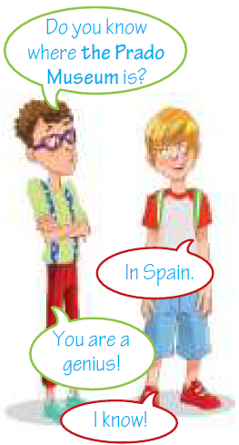  - Ask Ss to look at the cartoon and answer the questions.  - Ask Ss to work in pair to complete the task.  - Check Ss’ answers. | - Look at the cartoon and answer the questions.  - Work in pair to complete the task.  Answer keys:  -Ss’ own answer.

B. Presentation: 10 minutes
a. Objectives: to present the rules of Definite/Indefinite articles – Zero article.
b. Content: Theory box.
c. Expected outcomes: Ss can remember and understand the rules of Definite/Indefinite articles – Zero article.
d. Organization

Teacher’s activities | Students’ activities
Definite/Indefinite articles – Zero article.  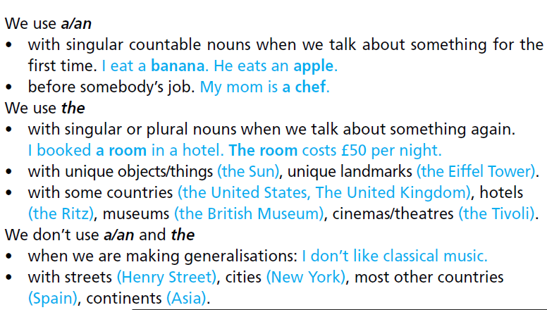  - Read out the theory and give examples.  - Ask Ss to study the theory box.  - Explain when we use/don’t use definite/ indefinite articles.  - Explain in Vietnamese if necessary. | - Read the theory box and listen to teacher’s explanation.  - Take notes.

C. Practice: 15 minutes
a. Objectives: to help Ss practise Definite/Indefinite articles – Zero article.
b. Content: task 5.
c. Expected outcomes: Ss can remember and understand Definite/Indefinite articles – Zero article, do the task correctly.
d. Organization:

Teacher’s activities | Students’ activities
Task 5. Fill in each gap with a/an, the or – (zero article).  - Explain the task and give Ss time to complete it.  - Check Ss’ answers (using the IWB). | - Fill in each gap with a/an, the or – (zero article).  Answer keys:  1 a / -/ the  2 -/ -/ a  3 the / an/ -  4 an/-/ the / the/ -  5 the/ -/ -/ -  6 the / the

D. Production: 10 minutes
a. Objectives: to help Ss use the language and information in the real situation.
b. Content: task 6.
c. Expected outcomes: Ss can make sentences using Definite/Indefinite articles – Zero article.
d. Organization

Teacher’s activities | Students’ activities
Task 6. Play in two teams. Make sentences using the names below. Each correct sentence gets one point. The team with the most points is the winner.  • Sun • Vietnam • Parthenon, Athens • Europe • Hanoi • Eiffel Tower • Ho Chi Minh City • Central Park • Hạ Long Bay • Vietnam Tuồng Theatre  Eg.The Earth goes round the Sun.  - Divide the class into two teams.  - Explain how to play the game and keep score. | - Play in two teams.  - Make sentences using the names given.  Suggested Answers:  S1: Vietnam is a southeast Asian country.  S2: The Parthenon is an ancient temple in Athens, Greece.  S3: Europe is a continent next to Asia.  S4: Hanoi is the capital city of Vietnam.  S5: The Eiffel Tower is a famous landmark in Paris, France.  S6: Ho Chi Minh City is the most crowded city in Vietnam.  S7: Central Park is a famous park in New York.  S8: Hạ Long Bay is a famous tourist attraction in Vietnam.  S9: The Vietnam Tuồng Theatre is in Hanoi.

E. Consolidation and homework assignments: 5 minutes
- Grammar point: Definite/Indefinite articles – Zero article.
- Do the exercises in workbook on page 30.
- Complete the grammar note in TA 7 Right On! Notebook page 24.
- Prepare the next lesson: Skills 3f (page 54).
5. Reflection

a. What I liked most about this lesson today:
…………………………………………………………………………………………
b. What I learned from this lesson today:
…………………………………………………………………………………………
c. What I should improve for this lesson next time:
…………………………………………………………………………………………

