Date of preparing: ………………………………….
Date of teaching: ………………………………….

Period……
UNIT 9: HOUSES IN THE FUTURE
Lesson 3 - Part 3 (Page 102, 103) – Review

I. OBJECTIVES
By the end of the lesson, Ss will be able to…
1. Knowledge
- review all vocabularies relating to houses in the future
- review all grammar points and pronunciation presented within the unit
2. Ability
- improve English skills
- develop the ability to communicate and cooperate with their partnerss, to self-study, to solve problems and other skills
3. Quality
- have a positive attitude in English language learning so that they actively participate in all classroom activities
II. TEACHING AIDS AND LEARNING MATERIALS.
Lesson plan, PPT slides, student’s book, workbook, notebook, personal computer (if any), projector/TV, speakers, DCR & DHA on EDUHOME, handouts…
III. PROCEDURES
A. Warm up: (5’)
a) Objective: to review vocabulary/ grammar presented within the unit
b) Content: a game
c) Product: Ss can recall the target language learnt
d) Competence: Collaboration, communication, presentation
e) Organization of the activity:
Teacher’s activities | Students’ activities
- Have Ss work in groups of 4  - Write as many vocabularies presented in the unit as possible (the one with the most correct items is the winner)  - Have groups cross check the work  - Announce the winner | - Do as guided  Vocabulary learnt  Smart home, megacity, earthscraper, eco-friendly home, underground, in a city, under the sea, on the sea, smart device, drone, screen, 3D printer, automatic food machine, robot helper, gravity, lock, float, spacesuit, the Moon, astronaut, space station, the Earth

B. New lesson (35’)
- Activity 1: Listening Skill (10’)
a) Objective: to have Ss practice the listening and test-taking skills
b) Content: Listening (page 102)
c) Products: Ss can improve their listening for details and be familiar with the test format
d) Competence: Collaboration, communication, analytical and synthesizing skills
e) Organization of the activity:
Teacher's activities | Students' activities
Listen to 5 short conversations. And choose the correct answers.  - Have Ss read the questions and guess the answers  - Play the audio twice, have Ss listen and choose the answer, take notes the key words  - Have Ss check the answer with a partner, list the key words they noted  - Check answer as a whole class.  - Ask Ss to give the cues for their answers.  - Play the audio again for Ss to check their answers. | - Read the questions and guess the answers  - Listen and answer the questions.  - Share their answers with partners.  - Give the cues for their answers.  Answer keys:  

- Activity 2: Reading Skill (10’)
a) Objective: to have Ss practice reading comprehension and test-taking skills
b) Content: Reading (page 102)
c) Products: Ss can improve their reading for details and be familiar with the test format
d) Competence: Collaboration, communication, analytical and synthesizing skills
e) Organization of the activity:
Teacher's activities | Students' activities
Read the three devices of the future and choose the correct answers.  - Have Ss study the task, read the questions, underline they key words  - Ask them to read and choose the answers, highlight where they found the answer in the reading texts  - Have Ss check the answer with a partner, explain why they chose that answer  - Check answer as a whole class.  - Ask Ss to give the cues for their answers. | - Work individually as guided  - Share the answers with a partner, give evidence for their answers  Answer keys:  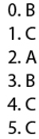

- Activity 3: Vocabulary (5’)
a) Objective: to review the vocabulary learnt
b) Content: Vocabulary (page 103)
c) Products: Ss can use the vocabulary learnt actively and correctly in communication
d) Competence: Communication, collaboration, analytical & synthesizing skills
e) Organization of the activity:
Teacher's activities | Students' activities
Fill in the blanks with words from the box.  - Ask Ss to explore the task (identify what is requested to do, look through all the vocabulary given)  - Have Ss work in pairs to identify what is needed for each blank  - Ask Ss to do the task individually.  - Have Ss share their answers with partners.  - Check answers as a whole class.  - Ask Ss to give reasons for their answers.  - Give feedback | - Do as guided  - Do the task individually.  - Share the answers with the partners.  - Present the answers.  Answer keys:  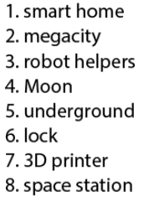

- Activity 4: Grammar (5’)
a) Objective: to review the grammar learnt
b) Content: Grammar (page 103)
c) Products: Ss can use the grammar learnt actively and correctly in communication
d) Competence: Communication, collaboration, analytical & synthesizing skills
e) Organization of the activity:
Teacher's activities | Students' activities
Write full sentences using the words below.  - Ask Ss to explore the task  - Ask Ss to do the task individually.  - Have Ss share their answers with partners.  - Check answers as a whole class.  - Ask Ss to give reasons for their answers.  - Give feedback | - Do as guided  - Do the task individually.  - Share the answers with the partners.  - Present the answers.  Expected answer:  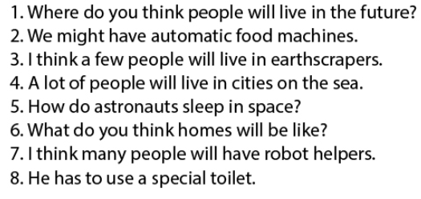

- Activity 5: Pronunciation (5’)
a) Objective: to review word stress and individual sound
b) Content: Pronunciation (page 109)
c) Products: Ss can be confident in producing speech
d) Competence: Communication, collaboration, analytical & synthesizing skills, presentation
e) Organization of the activity:
Teacher's activities | Students' activities
Circle the word that differs from the other three in the position of primary stress in each of the following questions.  - Ask Ss to explore the task  - Have them work individually  - Have them check the answers  - Have them practice saying them with a partner  - Walk around and correct wrong pronunciation if any  Circle the word which has the underlined part pronounced differently from the others.  - Ask Ss to explore the task  - Have them work individually  - Have them check the answers  - Have them practice saying them with a partner  - Walk around and correct wrong pronunciation if any | - Do as guided  - Do the task individually.  - Share the answers with the T  - Say them with a partner  Answer keys:  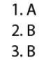  - Do as guided  - Do the task individually.  - Share the answers with the T  - Say them with a partner  Answer keys:  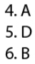

C. Consolidation (3’)
- Vocabularies, grammar points within the unit
- Pronunication and useful language
D. Homework (2’)
- Learn new words and practice with the new language of Unit 9.
- Do the exercise in the Workbook (Pages 70 & 71)
- Write a paragraph about your favorite home in future.
- Be well-prepared for the next lesson Unit 10 Lesson, page 78

