UNITS | VOCABULARY | GRAMMAR
Unit 7  TRANSPORTATION | - Vocabulary related to personal belongings  - Compare different types of transportation | - Possessive pronouns and adjectives in order  - “(not) as … as …”
Tiếng Anh 7 – i-LEARN SMART WORLD

UNIT 7 TEST
Note: Each correct answer earns 0.2 points.

I. PRONUNCIATION (0.8 points)
A. Choose the word whose underlined part is pronounced differently.
1. A. subway B. luggage C. public D. support
2. A. backpacks B. tickets C. customs D. passports
B. Choose the word that has a different stressed syllable from the rest.
3. A. around B. boarding C. baggage D. local
4. A. environment B. transportation C. reliable D. convenient

II. VOCABULARY AND GRAMMAR (2.4 points)
Choose the best option (A, B, C or D) to complete each of the following questions.
5. Make sure you don’t take the wrong bag at the __________.
A. custom B. security C. boarding D. baggage claim
6. Bicycles are __________ for the environment than cars.
A. better B. more C. as good D. the best
7. For commuting in our city, __________ form of transportation is the bus because it’s _________ than going by car or taxi.
A. the most popular / the cheapest B. the most popular / cheaper
C. more popular / cheaper D. more popular / the cheapest
8. There are __________ buses from Tân Sơn Nhất airport to the city center. Buses depart every 15 minutes.
A. friendly B. public C. easy D. frequent
9. Korea has excellent __________. The buses are regular and the trains are on time.
A. vehicle B. transport system
C. public transportation D. moving system
10. Person A: Is this Andy’s backpack?
Person B: No, it isn’t. He has a _________ backpack.
A. new big dark blue B. big new dark blue
C. dark blue big new D. new dark blue big
11. Person A: Whose suitcase is this?
Person B: It has Jodie and Jack’s names on it, so it must be _________.
A. their B. they C. them D. theirs
12. Officers will check your luggage when you go through __________.
A. airport B. baggage claim C. customs D. check-in
13. It’s very important to keep your __________ in a safe place. You need this document to enter or leave a foreign country.
A. passport B. boarding pass C. ticket D. luggage
14. Person A: Excuse me, does this bag belong to you?
Person B: _________. Thank you a lot.
A. Yes, it’s my.
B. Yes, it’s mine bag.
C. Yes, my bag is this.
D. Yes, it’s mine.
15. What does this sign on the plane mean?
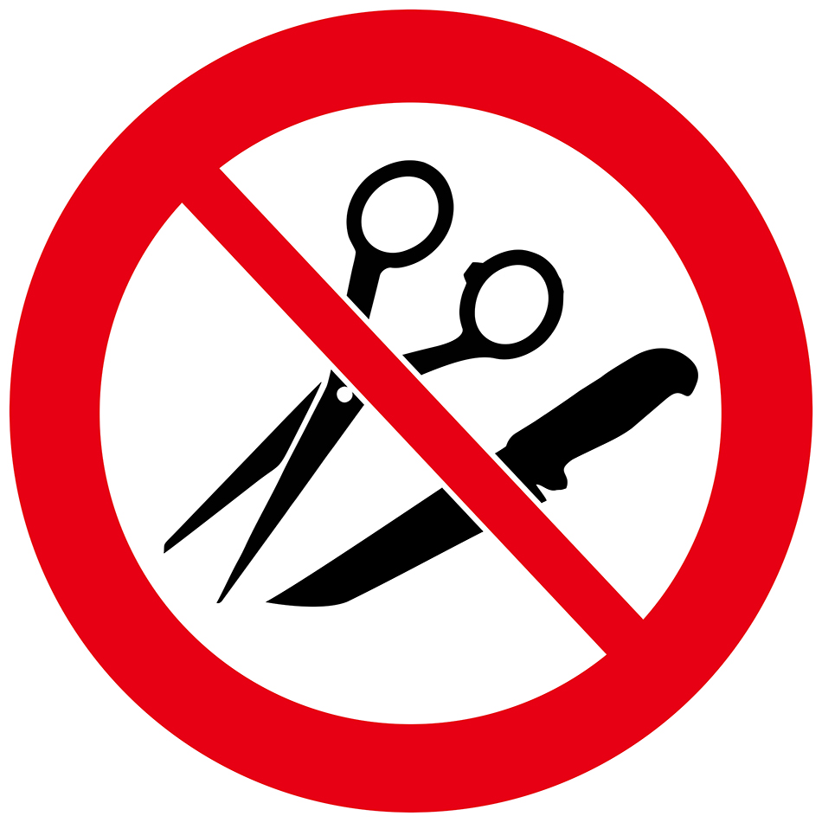 | A. You can’t use scissors and knives at the same time on the plane.  B. You can’t buy any scissors or knives on the plane.  C. You can’t bring any sharp objects on the plane.  D. You can’t use scissors or knives because they are sharp.

16. What does this sign mean?
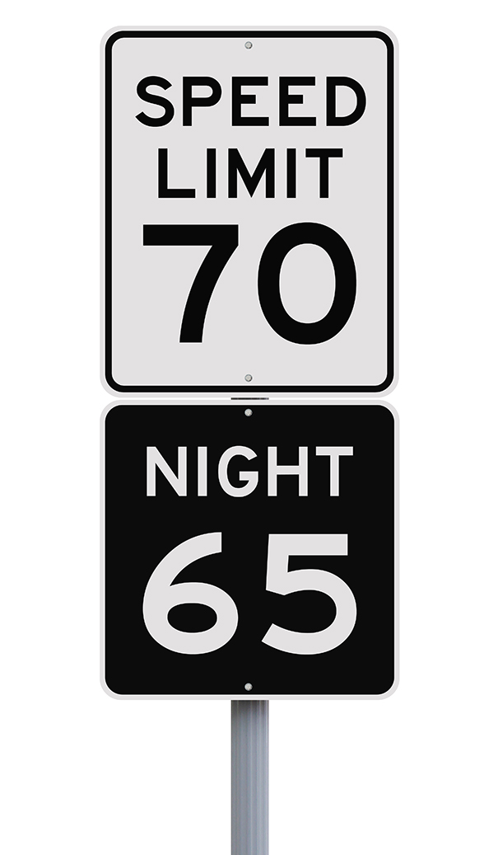 | A. You have to drive slower at night than during the day.  B. You can’t drive faster than 70 miles per hour at night.  C. You have to go at 65 kilometers per hour at night.  D. The fastest speed you can drive is 65 miles per hour.

III. WORD FORMATION (1.2 points)
Write the correct form and compound of the words in brackets.
17. I think electric cars are more ___eco-friendly_______ than petrol cars because they don’t produce air pollution. (FRIEND)
18. Buses in this country aren’t __reliable_________. They’re often late. (RELY)
19. Traveling by train is the best option for long-distance travel. They are clean, __comfortable________ and punctual. (COMFORT)
20. MTR (Mass Transit Railway), with ten lines and more than 70 stations, is the most _convenient_________ way of traveling in Hongkong. (CONVENIENCE)
21. I like traveling by motorbike because it’s a great way to get around Hồ Chí Minh city ___quickly_______. (QUICK)
22. In the UK, there are several ___different_______ kinds of public transportation. (DIFFER)
IV. LISTENING (2 points)
A. You will listen to a conversation about two types of transportation. Complete the table with ONE WORD for each blank.
 | Private transportation | Public transportation
Description | • better for (23)_short_ distances  Example: an electric (25)_scooter_ | • better for (24)_long_ distances  • more (26)_eco-friendly_  Example: a bus or a (27)_train_

B. Listen to the following conversation. For each question, write T if the statement is TRUE, F if is FALSE, and NI if there is NO INFORMATION.
28. The main topic of the conversation is about two guys traveling around the city. __F__
29. Steve had a wonderful time using public transportation to get around. __T__
30. Locals like to take the train because it’s cheap. __F__
31. Trains are usually not near the cities. __T__
32. The food on a train is better than on a bus. __NI__

V. READING (2 points)
A. Read the following passage. For each question, complete the notes with NO MORE THAN TWO WORDS.
Transportation has changed in many ways over the years. The oldest known form of transportation is the boat. Around 60,000 years ago, boats were made by hollowing out a tree trunk, also known as a canoe. Riders had to use paddles to control the canoe across the water. However, today boats are more convenient because they have an engine that powers them.
Next came horses. Surprisingly it took 55,000 years after the invention of the boat to discover horses as a means of transportation. At first, horses were ridden without a saddle, also called riding bareback. But over time, riders used saddles to make traveling more comfortable and easier to control the horse. After that, it didn’t take long for us to figure out we could use a wagon and a horse to help carry equipment and people.
This article is about how much (33)__transportation__ has changed over the years. Nearly 60,000 years ago, riders had to use a paddle to control the (34)__canoe__ across dangerous waters. Today, boats are more (35)__convenient__ because they have engines.
Riding a (36)__horse__ without a saddle is called riding bareback. People started using saddles to make it more (37)__comfortable__ and easier to control the horse.
B. Read the following passage. For each question, circle the correct option A, B, C, or D.
Last summer, I was planning on taking an airplane for the first time, but there were many things I didn’t know. For example, how many suitcases should I take or what can I bring in my backpack? So, I asked my mom for help, and she told me that the more luggage you bring, the more expensive the ticket is. So, she suggested bringing only the things I needed. She also told me not to take dangerous items like large batteries or sharp objects because I’ll have to go through customs. My mom also said not to lose my boarding pass or passport because I’d need them to get on the plane. Finally, she told me I needed to find the baggage claim after the airplane landed to pick up my suitcases. I’m happy my mom was able to help me know more about air traveling because it made the experience better.
38. The more luggage you bring,...
A. the more expensive the ticket is. B. the more it weighs.
C. the more trouble you can get in. D. the less you carry.

39. Why do you need a boarding pass and passport?
A. to leave the airport B. to get on the airplane
C. to bring your luggage D. to purchase food

40. Where do you pick up your suitcases after the airplane lands?
A. the ticket counter B. the lounge
C. the security office D. the baggage claim

41. Why is it important to know how to travel on an airplane?
A. The ticket is expensive. B. It makes the experience better.
C. Taking an airplane is faster. D. Bringing extra luggage costs more.

42. What is true about the story?
A. It’s important to use the seatbelt.
B. There are many places to eat at the airport.
C. There are many things to know about flying on an airplane.
D. You can get lost at the airport.

VI. WRITING (1.6 points)
A. Rewrite the following sentences without changing their meaning. Use the given word(s) if any.
43. During the rush hours in New York, cycling to work and going by bus take the same amount of time. (FAST)
→ During the rush hours in New York, cycling to work is as fast as going by bus.
44. An underground train across London costs £6 while a taxi costs £15. (CHEAPER)
→ An underground train across London is cheaper than a taxi.
→ Traveling across London by underground train is cheaper than traveling by taxi.
45. Heathrow Airport is currently busier than any other airports in the UK.
→ Heathrow Airport is currently the busiest airport in the UK.
46. No one else in my family drives better than my father.
→ My father is the best driver in my family.

C. Use the given words or phrases to make complete sentences.
47. I / think / travel / bus / be / relaxing / than / car.
→ I think traveling by bus is more relaxing than (traveling) by car.
48. This / be / not / my mother / handbag / because / hers / be / brown.
→ This is not my mother’s handbag because hers is brown.
49. Subway / be / popular / means of transportation / New York.
→ Subway is the most popular means of transportation in New York.
→ Subway is a popular means of transportation in New York.
50. I / prefer / ride my bike / school / because / it / healthy / take the bus.
→ I prefer riding my bike to school because it’s healthier than taking the bus.

***End – Of – Test***
Listening Scripts

Script A

Stacey: Today, I will be discussing, with my friend, Paul, the differences between public and private transportation. So Paul, which do you prefer?
Paul: Excellent question, Stacey. For me, it depends on several factors. For example, if traveling locally, I prefer private transportation. However, if traveling long distances, I like public transportation.
Stacey: Those are interesting points. So you’re saying that if you have to travel short distances, you would prefer to get there on your own with private transportation. But if you’re traveling a long way, it's better to take public transportation like a bus or train.
Paul: That’s correct. I take my electric scooter for short trips because I like to drive around the city. However, if the trip is far, it's easier to take faster and more eco-friendly transportation like a train.

Script B

Ryan: Welcome to my vlog! I’m Ryan, and today, I’m joined by my friend Steve. Today, we are talking about two types of transportation: buses and trains. Steve, what’s your experience been traveling around the country on buses and trains?
Steve: I’ve had a wonderful time using public transportation to travel around. First, buses are a great way to travel because they’re cheap and the locals like to use them.
Ryan: Yes, I agree. If you like to meet new people a bus is the best way to get around. How about a train?
Steve: A train is better if you want to see more of the country. Trains are usually away from cities, so you get a chance to see more farms and small villages.
Ryan: I took a train last year. I liked how comfortable it was, and we had lots of room and a bed.

