**Color and Properties of Oxygen in Different States**

Now the question is:

**What is the color of oxygen**? Well, gaseous oxygen is colorless. However, when in liquid form, it comes in a shade of pale sky-blue.

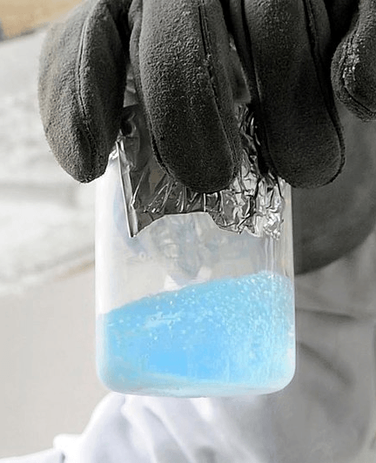Liquid oxygen in a beaker, showing its characteristic pale-blue color. Credit to U.S. Air Force photo/Staff Sgt. Jim Araos, via [Wikipedia](https://en.wikipedia.org/wiki/Liquid_oxygen).

The **color of solid oxygen**, on the other hand, ranges from light blue, pink-to-faint blue, faint-blue, orange, dark-red-to-black, and metallic in six of its different possible phases.

You basically can have solid dioxygen in 6 different phases. And each of them display a particular color.

## ****Why Is Liquid Oxygen Blue?****

Similarly to what happens to water (which is also blue, by the way!), the energetic transitions of the electrons in oxygen (which are also the cause of its para magnetism) absorb light on the red spectrum. So red light is absorbed to some extent, giving the substance its complementary color: blue.

If you want more info, [this paper](https://pubs.acs.org/doi/pdf/10.1021/ed042p647) in the Journal of Chemical Education gets you covered.

## ****Other Facts About Oxygen****

Oxygen is a fascinating chemical element. Apart from its physical and chemical properties, it also has a fascinating history. Add more to your new knowledge and digest some of the following facts below.

If you are hungry for even more, make sure to check our explanations to [100 chemistry facts](https://chemistryhall.com/fun-chemistry-facts/)!

### **Who Discovered Oxygen?**

The question of “who” only brings confusion as sources may vary.

The earliest mention of oxygen is in Michael Sendivogius’s 1604 study. A Polish philosopher, physician, and alchemist, he motioned that air contains a substance called ‘cibus vitae,’ which translates as the food of life.

However, most scholars say that the real discoverer of oxygen is Carl Wilhelm Scheele, a Swedish pharmacist. Between the years 1771 and 72, Scheele experimented with various metal salts, including several nitrates. Scheele discovered the release of a then-unknown combustible agent.

Scheele wrote in his manuscript, Treatise on Air and Fire, his observations about a so-called ‘fire gas’ that is released from heating nitrates. He submitted his findings in 1775 and had them published two years later.

During that same time, though, Joseph Priestley, an aptly named British clergyman, observed that mercuric oxide in a glass tube released a gas he called ‘dephlogisticated air’ after sunlight exposure. He further noted that candles burned brighter in ‘dephlogisticated air’ and that a mouse lived longer even after being exposed to it. He also tried breathing it in and noted that it was like breathing regular air. Priestley published these findings in his 1775 paper called An Account of Further Discoveries in Air.

On a different note, Antoine Lavoisier, also made claims that he independently discovered this substance. Both Lavoisier and Priestley exchanged correspondence and shared ideas. However, the former denied having received any letter from Carl Wilhelm Scheele.

### **Where Did Oxygen Originate on Earth?**

[Oxygen comes in third as the most abundant element across the whole universe](https://chemistryhall.com/composition-of-the-universe/). However this only accounts for about 1% of oxygen, since the two main constituents, hydrogen and helium, account for 75% and 23% of the entire universe, respectively.

But it was relatively scarce during the formation of Earth.

Accordingly to theories, early forms of cyanobacteria have produced oxygen and added it into the atmosphere of our then-prehistoric planet. Like plants of today, these organisms used photosynthesis as a form of sustenance. For millions of years, they took in carbon dioxide and released oxygen — a grand event dubbed as the [Great Oxidation Event](http://www.bbc.com/earth/story/20150701-the-origin-of-the-air-we-breathe).

### **What Is the Effect of O2 in the Blood?**

Oxygen is crucial to our bodily functions. Without it, we would not last long. Oxygen is not only the basic source of energy that fuels the activity of all cells in our body, but also has several other secondary functions such as serving as a buffering agent – keeping our pH levels in check.

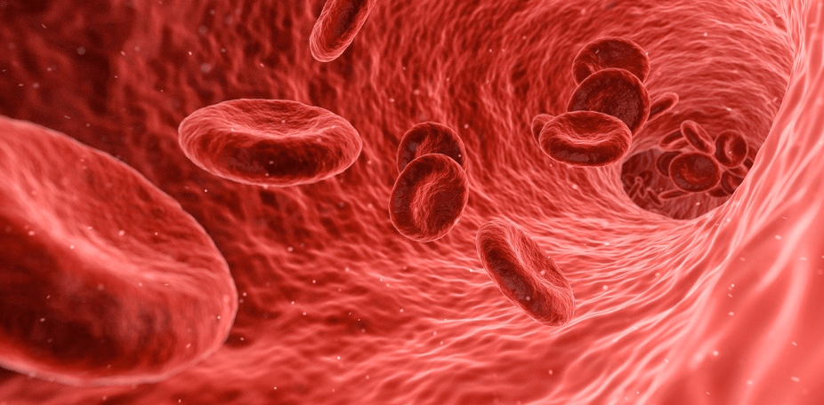Blood carries oxygen throughout our bodies.

The average blood O2 level is around 75-100 mm Hg or millimeters of mercury. When it drops below normal, we may experience shortness of breath. Likewise, our blood will become acidic because of an increase in blood carbon dioxide or CO2.

Now, what if blood O2 increases? We will experience hyperoxia, which, when aggravated, may lead to oxygen toxicity. This condition may also cause severe damage to your body.

### **Why Do We Turn Blue When Blood O2 Decreases?**

Bright red is the **color of oxygenated blood** because of the protein, hemoglobin. However, when a person experiences [hypoxia](https://www.mayoclinic.org/symptoms/hypoxemia/basics/definition/sym-20050930), hemoglobin will not bind with the red blood cells, resulting in a darker hue, making us appear as bluish.

Basically, oxygen forms a coordination complex with the ‘heme’ group on hemoglobin. This complex is red-colored, whereas free hemoglobin is actually blue.

### **Why Are Oxygen Atoms Usually Depicted in Red Color?**

If you are familiar with [molecular models](https://chemistryhall.com/best-organic-chemistry-model-kit/) (and you should!), for sure you know that oxygen atoms are usually red-colored.

Considering that these colors ([CPK coloring system](https://en.wikipedia.org/wiki/CPK_coloring)) are usually inspired by the color of the elements themselves (hydrogen is white since its always colorless, carbon is black because of charcoal, sulfur powder is yellow…) his seems counter-intuitive after everything we have just explained.

The inspiration for traditionally coloring oxygen atoms in red is not that clear. It probably has to do with oxygen being required for combustion (and fire is red), or due to the previous fact that we covered: oxygen makes hemoglobin look bright red!

## To Sum Up

And that concludes our discussion on this element.

So **what is the color of oxygen**, you say? Well, the answer is: it depends on its physical and chemical state. It is colorless when in gas form; pale or sky blue when in liquid, and shades of blue, red, and black-metallic when in solid state.

### **Related Posts:**