|  |  |
| --- | --- |
|  |  |

**Họ tên thí sinh: .................................................................**

**Số báo danh: ......................................................................**

**Mã Đề: 015.**

**Câu 1.** What is the offer for the swim class?

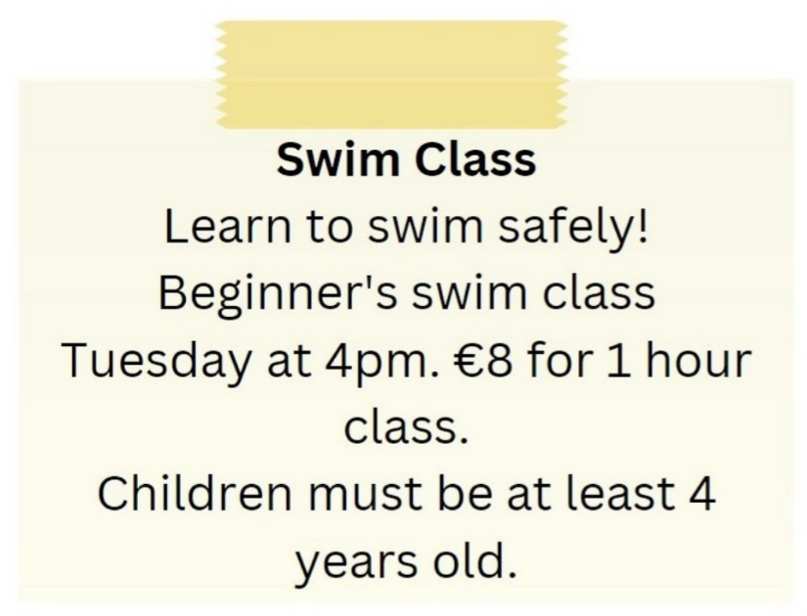

**A.** Beginner's swim class on Tuesday at 5pm for €10

**B.** Advanced swim class on Tuesday at 4pm for €8

**C.** Beginner's swim class on Wednesday at 4pm for €8

**D.** Beginner's swim class on Tuesday at 4pm for €8

**Câu 2.** Who is Andrew planning to go to the cinema with?

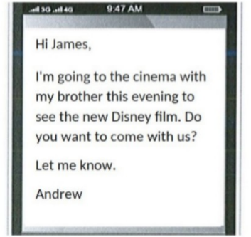

**A.** James  **B.** Alone  **C.** His parents  **D.** His brother

**Câu 3.** What does this sign mean?

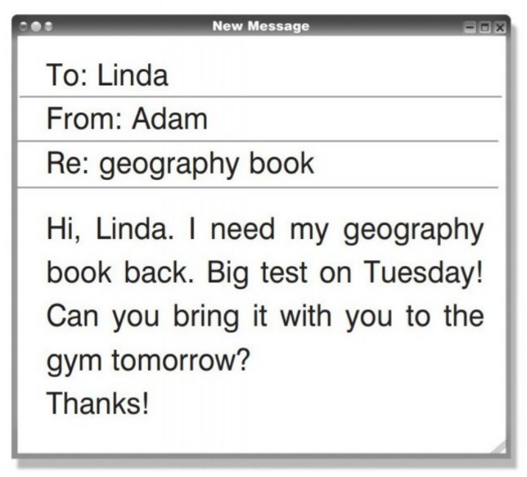

**A.** Linda wants to study in the fitness center.  **B.** Adam requests to take Linda's book.

**C.** On Tuesday, Adam has a geography exam.  **D.** The book belongs to Linda.

**Câu 4.** What does this sign mean?

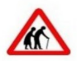

**A.** Be cautious as elderly people may be crossing the road.

**B.** Be careless as elderly people may be crossing the road.

**C.** They are wearing traditional clothing.

**D.** There are two old people here.

**Câu 5.** Which of the following is NOT mentioned as available at the Indoor Market?

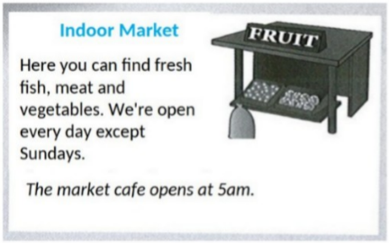

**A.** Vegetables  **B.** Dairy products  **C.** Meat  **D.** Fresh fish

**Câu 6.** What is true about the New Zealand advertisement?

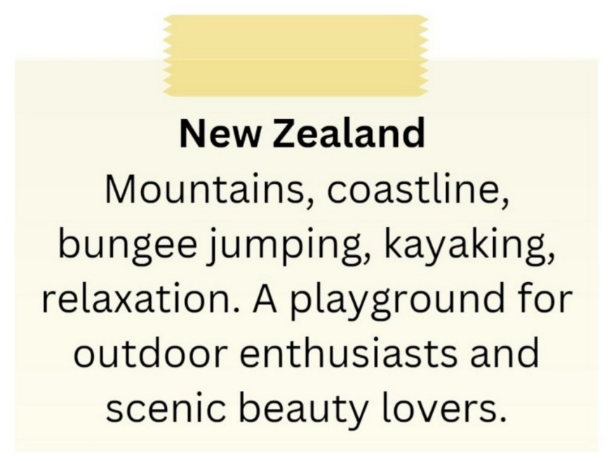

**A.** It primarily appeals to relaxation enthusiasts.

**B.** It is not suitable for outdoor enthusiasts.

**C.** It highlights mountains, coastline, bungee jumping, and kayaking.

**D.** It is a destination for indoor activities and cultural experiences.

**Câu 7.** What should visitors do if the gate is closed?

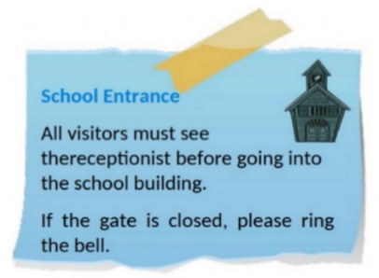

**A.** Wait for someone to open it  **B.** Come back later

**C.** Ring the bell  **D.** Call the school office

**Câu 8.** What can you see at the circus?

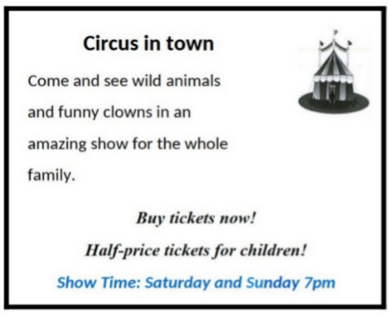

**A.** Only acrobats  **B.** Only wild animals

**C.** Only funny clowns  **D.** Wild animals and funny clowns

**Câu 9.** Who should students contact if they have lost their phone?

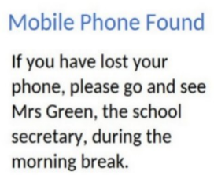

**A.** Their teacher  **B.** The janitor  **C.** Mrs Green  **D.** The principal

**Câu 10.** Who can participate in this cycle ride?

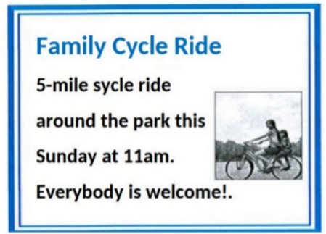

**A.** Only families with children  **B.** Anyone who wants to join

**C.** Only park members  **D.** Only experienced cyclists

**----HẾT---**