|  |  |
| --- | --- |
|  | *Thời gian làm bài: 40 phút (Không kể thời gian giao đề)*  *-------------------------* |

**Họ tên thí sinh: .................................................................**

**Số báo danh: ......................................................................**

**Mã Đề: 003.**

**Câu 1.** What is true about the New Zealand advertisement?

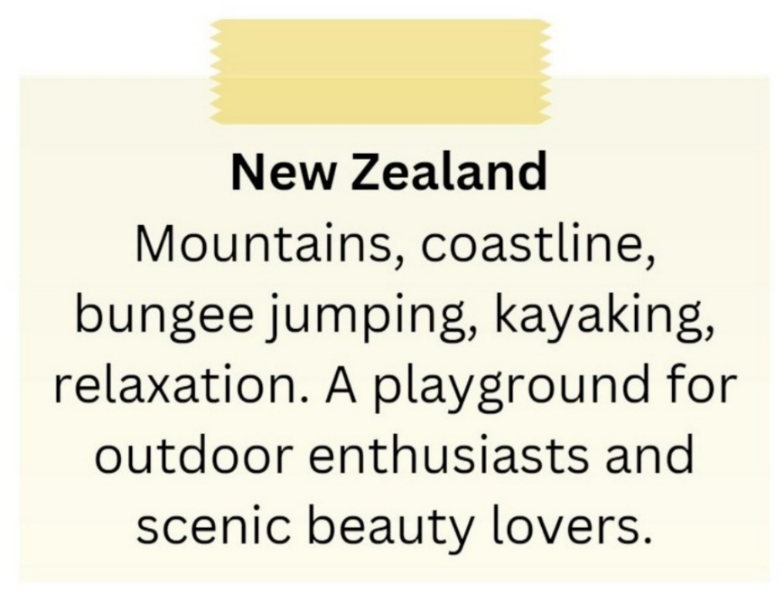

**A.** It is not suitable for outdoor enthusiasts.

**B.** It highlights mountains, coastline, bungee jumping, and kayaking.

**C.** It is a destination for indoor activities and cultural experiences.

**D.** It primarily appeals to relaxation enthusiasts.

**Câu 2.** Which of the following statements is true?

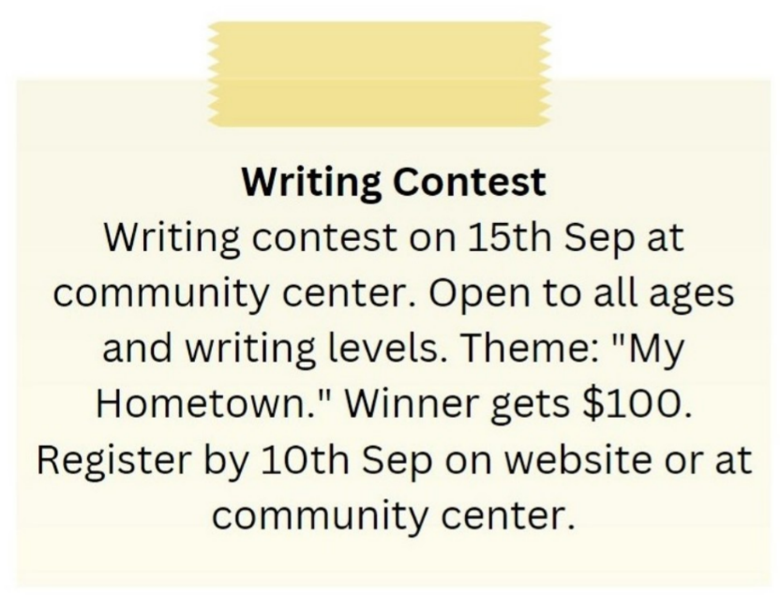

**A.** The writing contest is only open to experienced writers.

**B.** The English course starts on 1st September.

**C.** The theme of the writing contest is “My Hometown.”

**D.** The English course is for advanced learners.

**Câu 3.** How long is the flight to France?

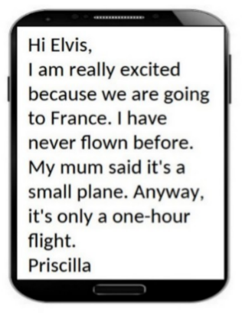

**A.** One hour  **B.** Three hours  **C.** Two hours  **D.** 30 minutes

**Câu 4.** What is the current promotion at the clothes store?



**A.** 10% discount on all clothes  **B.** Buy one get one free on summer dresses

**C.** Free T-shirt with every purchase  **D.** 20% discount on all clothes

**Câu 5.** What did the person run out of?

“Hi, I hope your day is going well. I ran out of notebook paper and I have a lot of notes to take in class today. Would it be possible for me to borrow some paper from you? I’ll make sure to return the favor if you ever need anything. Thank you!”

**A.** Pencil  **B.** Ruler  **C.** Notebook paper  **D.** Eraser

**Câu 6.** What activity is being proposed in the message?

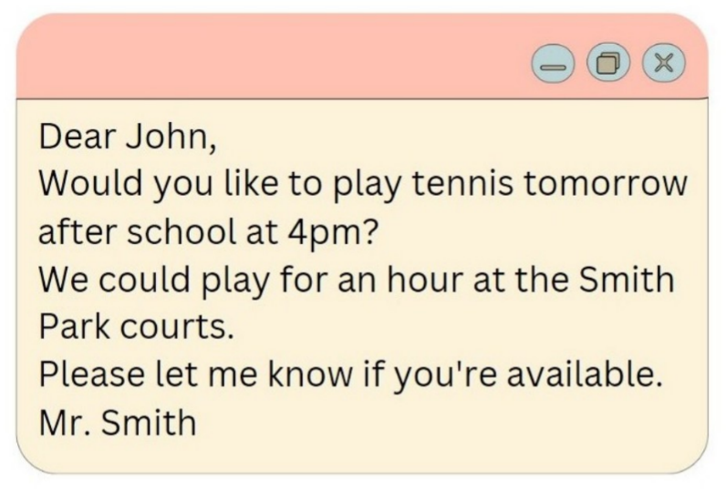

**A.** Playing basketball  **B.** Going for a run  **C.** Going swimming  **D.** Playing tennis

**Câu 7.** **Look at the signs. Choose the best answer for the question.**

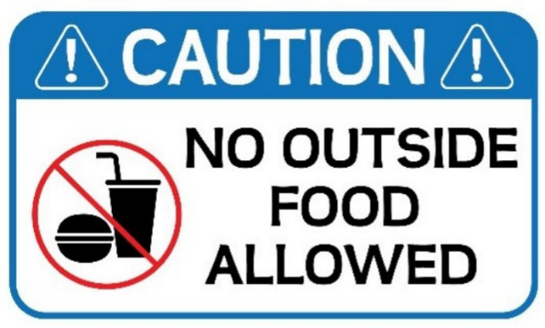

**A.** Food and drink are not allowed in this place.

**B.** Do not bring food or drink from outside into this place.

**C.** Do not eat or drink anything outside this place.

**D.** Be careful when eating and drinking outside this place.

**Câu 8.** Which of the following is NOT mentioned about the apartment?

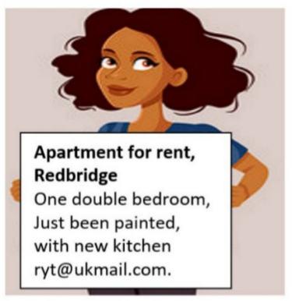

**A.** It has a double bedroom  **B.** It has a new kitchen

**C.** It has been recently painted  **D.** It has a balcony

**Câu 9.** **Look at the signs. Choose the best answer for the question.**

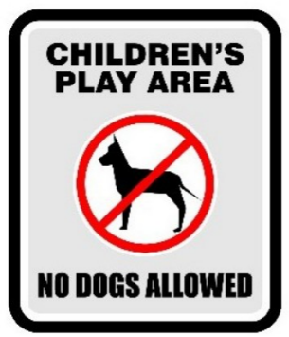

**A.** Dogs cannot be taken into this place as it is a children’s play area.

**B.** Dogs are not safe for children in this play area.

**C.** Dogs are not allowed to play with children in this area.

**D.** Don’t let your children play here because of the dogs.

**Câu 10.** **Look at the signs. Choose the best answer for the question.**

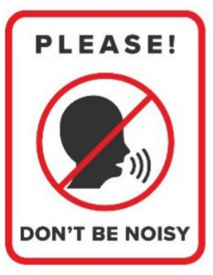

**A.** You don’t have to raise your voice in this area.  **B.** You shouldn’t speak to anyone in this area.

**C.** You must be quiet in this area.  **D.** You mustn’t talk in this area.

**----HẾT---**