Thời gian làm bài: 40 phút (Không kể thời gian giao đề)
-------------------------
Họ tên thí sinh: .................................................................
Số báo danh: ......................................................................
Mã Đề: 013.
Câu 1. What time was the theatre originally scheduled to open?
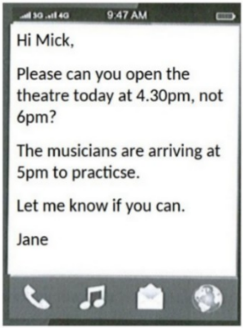
A. 6:00pm B. 5:30pm C. 5:00pm D. 4:30pm
Câu 2. What subject does John need help with?
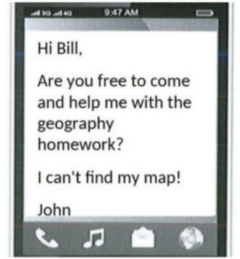
A. Math B. Geography C. History D. English
Câu 3. Look at the signs. Choose the best answer for the question.
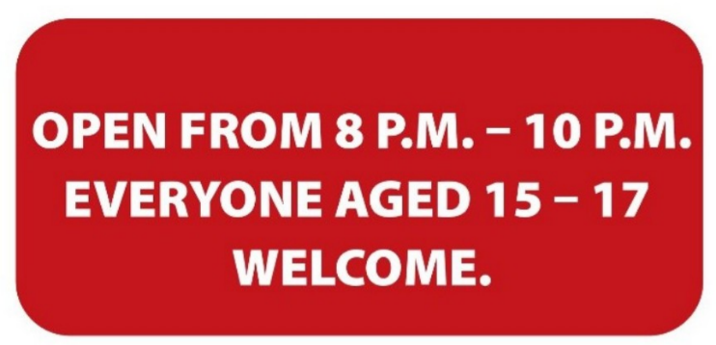
A. Teenagers aged 15-17 can visit the venue from 8 p.m. to 10 p.m.
B. The venue is open to all teenagers under the age of 17.
C. Only teenagers who are over 15 are allowed to enter this place.
D. Only 15-17 people can enter the place from 8 p.m. to 10 p.m.
Câu 4. Why has Jenna left a note for Marcus?
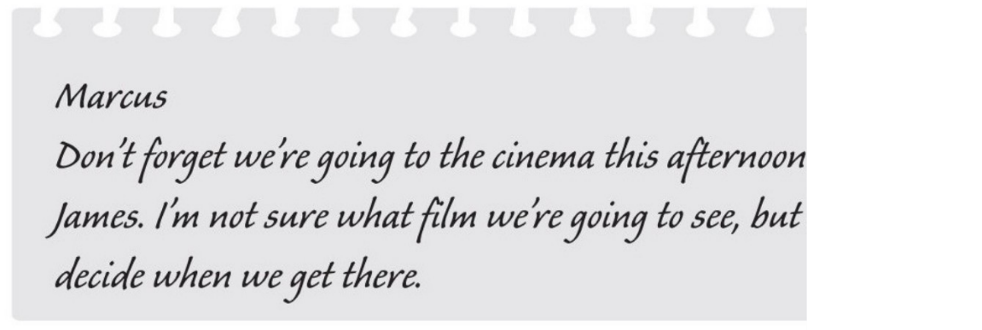
A. to remind him about an arrangement B. to invite him to the cinema
C. to suggest a film which they could see D. to choose the cinema
Câu 5. Which of the following services is NOT offered by the Village Shop?
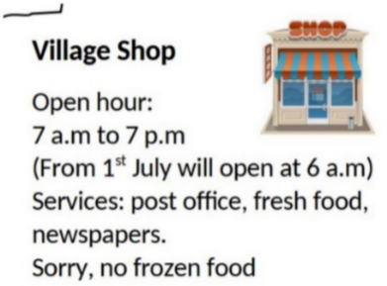
A. Post office B. Frozen food C. Fresh food D. Newspapers
Câu 6. What is the colour of the bin for composting according to the notice?
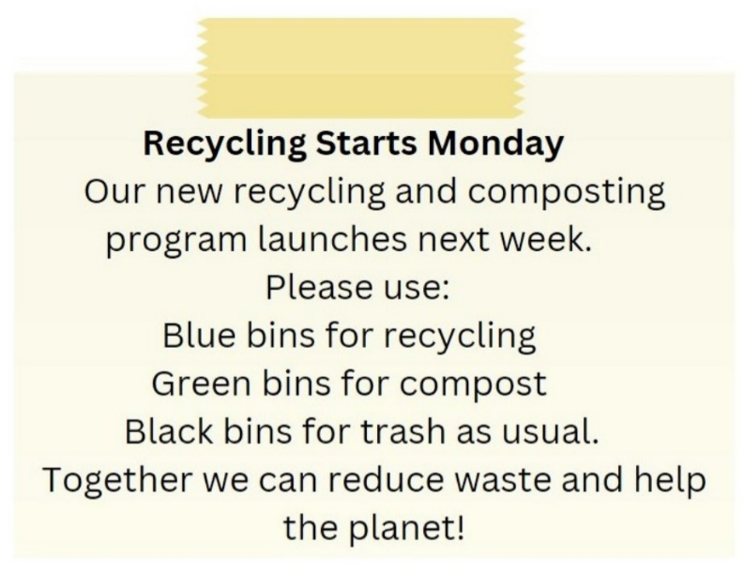
A. Black B. Green C. Blue D. Red
Câu 7. What is true about this notice?
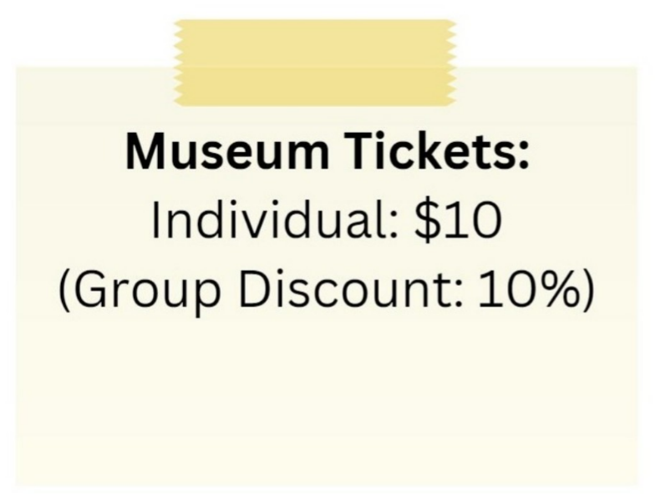
A. The group discount is 20%.
B. There is no group discount available.
C. The individual ticket price is $5.
D. The individual ticket price is $10 and there is a 10% group discount.
Câu 8. Look at the signs. Choose the best answer for the question.
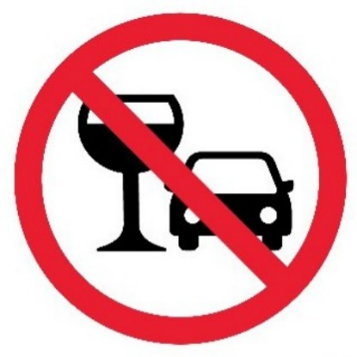
A. You mustn’t drink anything while you are driving.
B. You should stop driving if you want to drink water.
C. You are not allowed to drink alcohol before and while driving.
D. You cannot use glasses in the car.
Câu 9. Look at the signs. Choose the best answer for the question.
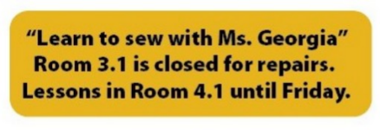
A. Ms. Georgia’s class will be on a different day. B. Ms. Georgia will repair her room on Friday.
C. There is a new location for Ms. Georgia’s class. D. Ms. Georgia isn’t coming to school until Friday.
Câu 10. Look at the signs. Choose the best answer for the question.
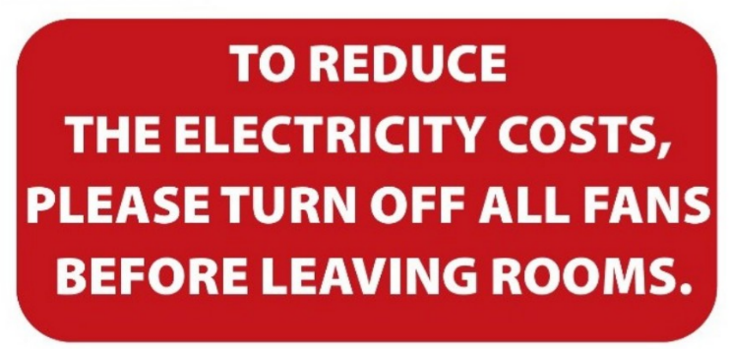
A. Please switch off fans when you finish using a room to save electricity.
B. Please reduce the costs of electricity by leaving the room.
C. When you leave, please reduce the number of fans in your room.
D. Please leave the fans in the room after you go out.
----HẾT---

