**The natural world and environment**

**Task 1. Find names of animals in the Wordlist mindmap that match the descriptions below.**

1 It lives in the sea. It’s grey and friendly. ______

2 It lives with lots of black and yellow friends. They can fly. ______

3 It’s got four legs and fur and it lives in Africa. It’s a dangerous animal which hunts and kills smaller animals. ______

4 It lives in seas and rivers and it’s pink when it’s cooked. It’s very good to eat! ______

5 It’s black and white and it’s got wings. It lives in cold places. ______

6 It’s small with red fur. It’s got a long tail. It lives in the forest. ______

7 It’s very small and black. It’s got six legs and it lives with many friends under the ground. ______

8 It’s like a dog but bigger. It’s grey with fur. It attacks smaller animals. ______

**Task 2. Complete the sentences with the correct forms of the words in capitals.**

1 Crocodiles are very ______. DANGER

2 We watched a documentary about the story of human ______ over the last three million years. EVOLVE

3 Be careful! Are you sure this mushroom isn’t ______? POISON

4 Air ______ is damaging jungles and forests. POLLUTE 5

It was really ______ yesterday – I couldn’t see anything! FOG

6 The ______ part of Poland has lots of mountains. SOUTH

7 It was lovely and ______ on holiday. SUN

8 It was so ______ yesterday – our garden chairs blew away. WIND

**Task 3. Complete the text with the words in the box. There are two extra words.**

Poland is a beautiful country with lots of interesting places to visit. In the 1 ______ and east of the country there are large lakes where people can 2 ______ fish, swim and sail. There are also sandy 3 ______ which are popular with tourists. In the south of the country there are 4 ______ which are great for walking and skiing in the winter. My favourite place to visit in this area is Góry Stołowe (Stolowe Mountains) – it’s an amazing place to walk through lots of 5 ______. They are different shapes and sizes because of the weather. There are also many large green 6 ______ in Poland – one of the most famous is called Białowieża National Park and it’s a UNESCO World Heritage site.

**WORDLIST**

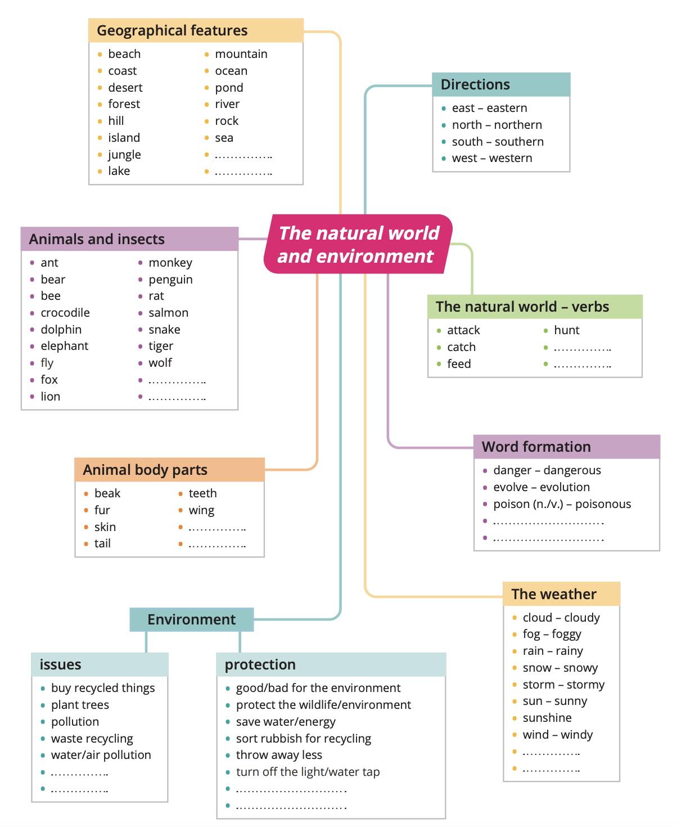

**ANSWER KEY**

**Task 1.**

1. dolphin 2. bee 3. lion 4. salmon

5. penguin 6. fox 7. ant 8. wolf

**Task 2.**

1. dangerous 2. evolution 3. poisonous 4. pollution

5. foggy 6. southern 7. sunny 8. windy

**Task 3.**

1. north 2. catch 3. beaches

4. mountains 5. rocks 6. forests