Unit 3 Test
I. Listening
Listen to Nancy talking about his best friend and fill in each blank with ONE word.
Information | Answer
Name of Nancy´s best friend | (1) __________
Appearance | short black hair and big (2) __________
Personality | kind, creative and very (3) __________
Favourite activity | taking (4) __________
Activity at the moment | making a poster for the school (5) __________
II. Pronunciation
A. Choose the word whose bold part is pronounced differently.
6. A. big B. biscuit C. picnic D. blonde
7. A. pear B. pen C. picnic D. best
B. Choose the word that has a different stress pattern from the others.
8. A. creative B. appearance C. confident D. important
9. A. appearance B. creative C. important D. comfortable
III. Language use
Choose the best answer A, B, C or D.
10. Lan is very __________. She always helps her classmates.
A. kind B. lazy C. noisy D. late
11. Nam has short black hair and __________ eyes.
A. big B. long C. curly D. blonde
12. Look! The boys __________ football in the playground.
A. play B. plays C. are playing D. is playing
13. My sister __________ a book at the moment.
A. reads B. is reading C. read D. are reading
14. What __________ your best friend like? - She is clever and friendly.
A. is B. does C. do D. are
15. Phong often takes photos. He is very __________.
A. creative B. boring C. shy D. lazy
IV. Signs & Notices
Look at the signs/notices and choose the best explanation.
16. Read the notice.
FRIENDSHIP CLUB
Meet new friends every Friday after school.
A. Students can meet new friends each Friday.
B. Students must study alone every Friday.
C. Students cannot talk to friends at school.
D. Students have no clubs after school.
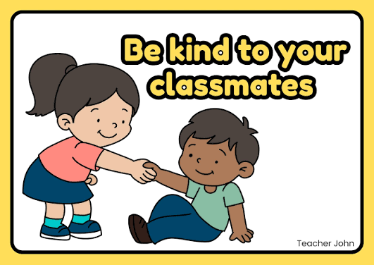
17. What does this sign mean?
A. You should work alone all the time.
B. You should laugh at your classmates.
C. You should help and be nice to your classmates.
D. You should talk loudly in class.
18. Read the notice. What is TRUE?
SUMMER CAMP PHOTO TIME:
Please stand with your group and smile.

A. Students are going to clean the board.
B. Students are going to take a group photo.
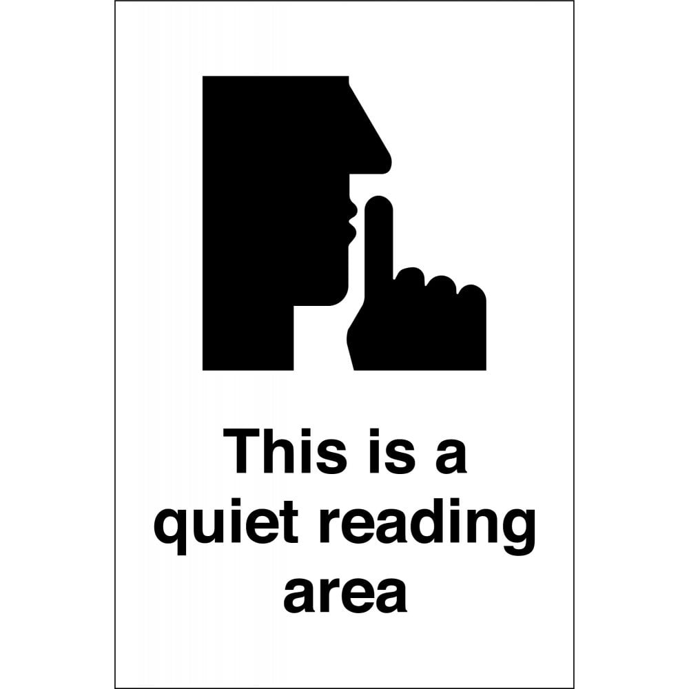
C. Students are going to sing in a group.
D. Students are going to do homework.
19. What does this notice tell you?.
A. You should read quietly here.
B. You can play football here.
C. You should read loudly here.
D. You can run and jump here.
V. LOGIC
Rearrange the sentences (a-d) to make a complete conversation.
20.
a. Mi: She is short with long black hair.
b. Linda: What does your best friend look like?
c. Linda: What is she like?
d. Mi: She is very kind and creative.
A. b-a-c-d B. b-c-a-d C. c-d-b-a D. a-b-c-d
21.
a. Nam: No, I am not. I am writing a letter.
b. Lan: Are you reading a comic book?
c. Lan: It is for my best friend.
d. Nam: Who is the letter for?
A. b-a-c-d B. a-b-c-d C. b-a-d-c D. c-d-b-a
22.
a. Phong: Because he is friendly and funny.
b. Vy: Who is your best friend?
c. Vy: Why do you like him?
d. Phong: My best friend is Nam.
A. b-d-c-a B. b-a-c-d C. d-b-a-c D. c-a-b-d
23.
a. Ba: They are playing badminton.
b. Anna: What are Duong and Hung doing?
c. Anna: Are they playing football?
d. Ba: No, they are not.
A. b-a-c-d B. c-d-b-a C. b-c-d-a D. a-b-c-d
VI. READING
A. Read and choose the correct word for each blank.
My best friend is Lan. She is twelve years old. She has long black hair and big eyes. Lan is very (24) _________ because she always helps other students. She is also creative. At the moment, she is (25) _________ a picture for our class magazine. We often do homework together, (26) _________ we sometimes play badminton after school. I like Lan because she is friendly and (27) _________.
24. A. kind B. lazy C. boring D. late
25. A. drawing B. draw C. draws D. to draw
26. A. or B. but C. and D. because
27. A. careful B. dirty C. noisy D. heavy
B. Read the text and choose the best answer A, B, C or D.
My name is Mi. My best friend is Chi. We are in Class 6A. Chi is tall and slim. She has short black hair and a small nose. She is very active. She likes sports and often plays badminton after school. She is also kind. When I do not understand my English homework, she helps me. Today, Chi is not playing badminton. She is preparing for our summer camp. She is packing her backpack and checking her camera because she likes taking photos. I think Chi is a good friend because she is friendly, helpful and creative.
28. What is the text mainly about?
A. Mi's school subjects B. Mi's best friend C. Chi's house D. A sports lesson
29. What class are Mi and Chi in?
A. Class 6A B. Class 7A C. Class 6B D. Class 5A
30. What does Chi look like?
A. She is tall and slim. B. She is short and fat.
C. She has long blonde hair. D. She has big ears.
31. What sport does Chi often play after school?
A. Football B. Badminton C. Basketball D. Table tennis
32. What does Chi do when Mi does not understand English homework?
A. She helps Mi. B. She laughs at Mi. C. She goes home. D. She takes photos.
33. What is Chi doing today?
A. Preparing for summer camp B. Playing badminton
C. Watching TV D. Cooking dinner
34. Why does Chi check her camera?
A. Because she likes taking photos. B. Because she is drawing a picture.
C. Because she is going swimming. D. Because she is reading a book.
35. Which word best describes Chi?
A. Helpful B. Lazy C. Noisy D. Careless
VII. WRITING
A. Rearrange the words to make complete sentences.
36. best friend / has / My / short black hair /.
______________________________________________________________________
37. are / They / playing badminton / at the moment /.
______________________________________________________________________
B. Rewrite the sentences without changing their meanings.
38. Lan is kind and creative.
Lan has ________________________________________________________________.
39. Nam is reading a book now.
At the moment, ________________________________________________________.
40. What does your best friend look like?
Can you tell me ______________________________________________________?

THE END!
AUDIO SCRIPT (PHẦN I: LISTENING)
Nancy is talking about her best friend.
My best friend is Nam. He is in my class. Nam has short black hair and big eyes. He is kind because he often helps his friends. He is also creative and very funny. At break time, he likes telling short stories, and everyone laughs. He loves taking photos, too. Today he is not playing football. He is making a poster for the school magazine. I like Nam because he is friendly and always makes our class happy.
*************************************
Đáp án tham khảo
Listening: 1. Nam | 2. eyes | 3. funny | 4. photos | 5. magazine
II. Pronunciation: 6. C | 7. D | 8. C | 9. D
III. Language use: 10. A | 11. A | 12. C | 13. B | 14. A | 15. A
IV. Signs & Notices: 16. A | 17. C | 18. B | 19. D
V. Logic: 20. A | 21. C | 22. A | 23. B
VI. Reading: 24. A | 25. A | 26. C | 27. A | 28. B | 29. A | 30. A | 31. B | 32. A | 33. A | 34. A | 35. A
VII. Writing:
36. My best friend has short black hair.
37. They are playing badminton at the moment.
38. Lan has a kind and creative personality.
39. At the moment, Nam is reading a book.
40. Can you tell me what your best friend looks like?

