School:
Teacher’s name:
Class:

LESSON PLAN
(Based on Official Letter No. 5512/BGDĐT-GDTrH dated December 18, 2020 of the MOET)

UNIT 2: MY HOUSE
Lesson 1: Getting started – A look inside

I. OBJECTIVES
By the end of this lesson, Ss will be able to:
1. Knowledge
- use the lexical items related to the topic My house
- ask and answer about where someone lives
2. Competences
- Develop communication skills and creativity
- Be collaborative and supportive in pair work and teamwork
3. Personal qualities
- Love and proud of all family members
- Be responsible with the housework and take care of all family members
- Actively join in class activities

II. MATERIALS
- Grade 6 textbook, Unit 2, Getting started
- Computer connected to the Internet
- Projector / TV
- hoclieu.vn

Language analysis
Form | Pronunciation | Meaning | Vietnamese equivalent
1. town house (n) | /ˈtaʊn ˌhaʊs/ | a house in a town or city, usually a comfortable, expensive one in a fashionable area | nhà ở thành phố
2. country house (n) | /ˌkʌntri ˈhaʊs/ | a large traditional house in the countryside, especially one that has belonged to the same family for many years | nhà ở vùng quê
3. flat (n) | /flæt/ | a set of rooms for living in that are part of a larger building and are usually all on one floor | căn hộ

Assumption
Anticipated difficulties | Solutions
1. Students may lack knowledge and experiences about the topic. | Prepare some handouts.
2. Students may have underdeveloped listening, speaking and co-operating skills. | - Play the recording many times if necessary.  - Encourage students to work in pairs, in groups so that they can help each other.  - Provide feedback and help if necessary.

III. PROCEDURES
1. WARM-UP (5 mins)
a. Objectives:
- To activate students’ knowledge on the topic of the unit.
- To set the context for the listening and reading part.
- To enhance students’ skills of cooperating with team mates.
b. Content:
- The hidden word
c. Expected outcomes:
- Students can answer some questions of the teacher about school
d. Organisation:

TEACHER’S ACTIVITIES | STUDENTS’ ACTIVITIES | CONTENTS
Game: The hidden words  - Teacher divides the class into two teams and asks a member of each team to look at the pictures and answer the questions.  - For each correct answer, the team will get 1 point and 1 secret letter to help them find out the hidden words today.  - There is one picture including two secret words. The team that gets this picture will get 2 points.  - The team which has more points or can guess the hidden words first will be the winner. | - Students work in 2 teams and follow the teacher's instruction to play the game. | Questions and answer key:  1. What is it? – It’s a _ _ _ _. (ROOM)  2. We have a small house in the _ _ _ _ _ _ _. (COUNTRY)  3. Where are they? – They are in the _ _ _ _ _ _ _. (KITCHEN)  4. They have a house in the _ _ _ _. (TOWN)  5. Which house is it? – It’s an _ _ _ _ _ _ _ _ _. (APARTMENT)
e. Assessment
- T checks Ss’ answers and gives feedback.

2. ACTIVITY 1: PRESENTATION (5 mins)
a. Objectives:
- To provide students with vocabulary.
- To help students be well-prepared for the task.
b. Content:
- Vocabulary pre-teaching
c. Expected outcomes:
- Students can identify some new words related to the topic house.
d. Organisation

TEACHER’S ACTIVITIES | STUDENTS’ ACTIVITIES | CONTENTS
Vocabulary pre-teaching  - Teacher introduces the vocabulary by:  + showing the pictures illustrating the words  + providing the synonym or antonym of the words  + providing the definition of the words | - Students guess the meaning of words. | New words:  1. town house (n): [visual]  2. country house (n): [visual]  3. flat (n): [synonym: apartment]
e. Assessment
- Teacher checks students’ pronunciation and gives feedback.

3. ACTIVITY 2: PRACTICE (20 mins)
a. Objectives:
- To introduce the topic of the unit
- To help Ss learn words and phrases related to types of house;
- To help Ss understand the text, then ask and answer about their own places
b. Content:
- Task 1: Listen and read.
- Task 2: Which family members does Mi talk about? Put a tick.
- Task 3: Read the conversation again. Complete each sentence with one word.
- Task 4: Complete the word web. Use the words from the conversation and the ones you know.
c. Expected outcomes:
- Students understand the conversation and topic of the lesson, gain knowledge of the vocabulary about types of houses.
d. Organisation

TEACHER’S ACTIVITIES | STUDENTS’ ACTIVITIES | CONTENTS
Task 1: Listen and read. (6 mins)
- Teacher asks students some questions before listening.  - Teacher plays the recording and asks students to underline the words related to the topic My house. (Teacher may check the meaning of some words if necessary.)  - Teacher can play the recording more than once.  - T can invite some pairs of students to read aloud. | - Students guess the answers to the questions.  - Students underline the words related to the topic.  - Students listen and read.  - Some pairs read aloud the dialogue. | Questions:  1. What are Nick and Mi doing?  They are talking online with each other.  2. What might they talk about?  They are talking about their house.
Task 2: Which family members does Mi talk about? Put a tick. (4 mins)
- Teacher asks students “Which family members does Mi talk about?” without reading the conversation again.  - Then, teacher tells them to read it again individually and check their answers.  - Teacher allows students to share their answers before discussing as a class and encourages them to give evidence.  - Teacher calls some students to check. | - Students do the task without reading the conversation again.  - Then Ss read again to check individually.  - Students share and discuss the answers. | Answer key:  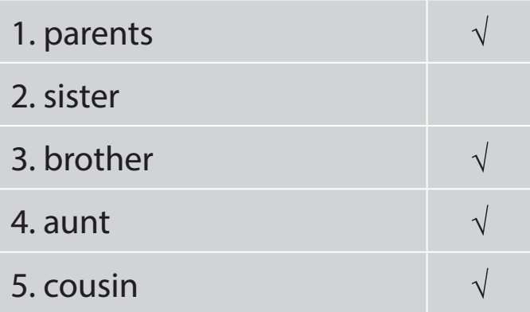
Task 3: Read the conversation again. Complete each sentence with one word. (5 mins)
- Teacher asks students to work  independently to fill each blank with the word from the conversation.  - Teacher allows students to share their answers before discussing as a class.  - Teacher calls some students to check. Teacher confirms the right answers and writes on the board. | - Students do the task individually.  - Share answers before discussing as a class. | Answer key:  1. sister  2. TV  3. town  4. country  5. three
Task 4: Complete the word web. Use the words from the conversation and the ones you know. (5 mins)
- Teacher divides the class into two teams, then writes the topic “Types of house” on the board and gives them two minutes to discuss.  - After that time, a student from each team one by one runs to the board and writes one word.  - The team which has more correct answers is the winner. | - Students work in 2 teams to do the task.  - Discuss and list as many types of house as possible. | Suggested answer:  Types of house: villa, cottage, flat, country house, stilt house, farmhouse,…
e. Assessment
- Teacher checks students’ exercises individually and gives feedback.

4. ACTIVITY 3: PRODUCTION (10 mins)
a. Objectives:
- To help students practise asking and answering about where they live.
- To check students’ vocabulary and improve group work skills.
b. Content:
- Task 5: Work in groups. Ask your friends where they live. Then report their answers.
c. Expected outcomes:
- Ss can list many words related to school things that they know.
d. Organisation

TEACHER’S ACTIVITIES | STUDENTS’ ACTIVITIES | CONTENTS
Task 5: Work in groups. Ask your friends where they live. Then report their answers.
- Teacher asks students to work in groups of 4 or 6 to take turns to ask and answer about where they live.  - Teacher can model with one student.  - Teacher moves around to observe and offer help when needed. By the end of the activity, one student from each group can stand up and report to the class. | - Students work in groups of 4 or 6 to do the task.  - One student from each group reports the answer to the class. | Suggested answers:  In my group, Linh lives in a flat, Lan and Huong live in a country house, etc
e. Assessment
- T and other Ss listen to the answers and give comments.

5. CONSOLIDATION (5 mins)
a. Wrap-up
- Teacher asks students to talk about what they have learnt in the lesson.
b. Homework
- Do exercises in the workbook.
- Start preparing for the Project of the unit:
Teacher randomly puts Ss in groups of 4 or 5 and asks them to brainstorm about a strange house and draw a picture of it. Students will show and present in Lesson 7 – Looking back and Project. (Teacher should check the progress of students’ preparation after each lesson.)

Board plan
Date of teaching
Unit 2: My house
Lesson 1: Getting started
* Warm-up

* Vocabulary
1. town house (n)
2. country house (n)
3. flat (n)

Task 1: Listen and read.
Task 2: Tick.
Task 3: Read and complete.
Task 4: Complete the word web.
Task 5: Ask and report.

*Homework

UNIT 2: MY HOUSE
Lesson 2: A closer look 1

I. OBJECTIVES
By the end of this lesson, Ss will be able to:
1. Knowledge
- Use the lexical items related to the topic My house;
- Use the vocabulary and structures to talk about the names of rooms and furniture in the house;
- Recognise and pronounce correctly the sounds /s/ and /z/.
2. Competences
- Be collaborative and supportive in pair work and teamwork
- Access and consolidate information from a variety of sources
3. Personal qualities
- Love and proud of all family members
- Be responsible with the housework and take care of all family members
- Develop self-study skills

II. MATERIALS
- Grade 6 textbook, Unit 2, A closer look 1
- Computer connected to the Internet
- Projector / TV
- hoclieu.vn

Language analysis
Form | Pronunciation | Meaning | Vietnamese equivalent
1. hall (n) | /hɔːl/ | the area just inside the main entrance of a house, apartment, or other building that leads to other rooms and usually to the stairs | đại sảnh
2. chest of drawers (n) | /ˌtʃest əv ˈdrɔːz/ | a piece of furniture with drawers in which you keep things such as clothes | tủ ngăn kéo
3. sink (n) | /sɪŋk/ | a bowl that is attached to the wall in a kitchen or bathroom in which you wash dishes or your hands, etc. | bồn rửa
4. dishwasher (n) | /ˈdɪʃˌwɒʃə(r)/ | a machine that washes dirty plates, cups, forks, etc. | máy rửa bát
5. cupboard (n) | /ˈkʌbəd/ | ​a piece of furniture or a space for storing things, with a door or doors and usually with shelves. | tủ (có ngăn)

Assumption
Anticipated difficulties | Solutions
Students may have difficulties in distinguishing two sounds /s/ and /z/. | Provide students some tips by identifying the letters that may include each sound.
Students may lack knowledge about some lexical items. | Provide students with the meaning and pronunciation of some lexical items.

III. PROCEDURES
1. WARM-UP (5 mins)
a. Objectives:
- To activate students’ prior knowledge and vocabulary related to the topic.
b. Content:
- Game: Jumbled word and matching (Task 1)
c. Expected outcomes:
- Students can recall some words about rooms in a house.
d. Organisation:

TEACHER’S ACTIVITIES | STUDENTS’ ACTIVITIES | CONTENTS
Game: Jumbled word and match (Task 1)
- Teacher asks students to work independently to rearrange letters to find out the correct word, then match the word with the picture.  - Teacher tells students to compare their answers with their partners.  - Teacher corrects and confirms the answers. | - Students do the tasks independently.  - Compare the answers with their partners. | * Jumbled words  1. tchekin ⭢ kitchen  2. thraobom ⭢ bathroom  3. rodeomb ⭢ bedroom  4. lngivi moro ⭢ living room  5. lahl ⭢ hall  * Matching  a. hall  b. living room  c. bedroom  d. bathroom  e. kitchen
e. Assessment
- Teacher’s feedback.

2. ACTIVITY 1: VOCABULARY (20 mins)
a. Objectives:
- To provide students with vocabulary.
- To revise / introduce the names of rooms in the house, furniture
- To help students practise asking and answering about the furniture in a room.
b. Content:
- Vocabulary pre-teaching
- Task 2: Name the things in each room in 1. Use the word list below. (You may use a word more than once.)
- Task 3: Think of a room in your house. In pairs, ask and answer questions to guess it.
c. Expected outcomes:
- Students can identify some new words about house and furniture.
d. Organisation

TEACHER’S ACTIVITIES | STUDENTS’ ACTIVITIES | CONTENTS
Vocabulary pre-teaching (6 mins)
- Teacher introduces the vocabulary by:  + providing the synonym or antonym of the words  + providing the pictures of the words | - Students guess the meaning of the words through pictures, synonyms or antonyms. | New words:  1. hall (n)  2. chest of drawers (n)  3. sink (n)  4. dishwasher (n)  5. cupboard (n)
Task 2: Name the things in each room in 1. Use the word list below. (You may use a word more than once.) (6 mins)
- Teacher asks students to work in pairs to do this activity.  - Teacher writes the names of the rooms on the board in different places, then calls on students from different pairs to go to the board and write the name of the furniture under these rooms.  - Remind students that one piece of furniture can belong to more than one room.  - Teacher asks other students to comment and asks them if they can add some more things to each room. | - Students work in pairs to do the task.  - Students come to the board to write the name of furniture. | Answer key:  Bedroom: lamp, chest of drawers, picture  Living room: lamp, picture, sofa  Hall: picture  Kitchen: cupboard, dishwasher, sink, fridge  Bathroom: toilet, shower, sink  Other words: chair, fan, air conditioner, cooker, etc
Task 3: Think of a room in your house. In pairs, ask and answer questions to guess it. (8 mins)
- Teacher models this activity with a student.  - Teacher asks students to work in pairs: one student thinks of a room in his / her house; the other asks questions to guess the room.  - Teacher calls some pairs to practise in front of the class.  - Teacher comments on their performance. | - One student models the activity with the teacher.  - Students work in pairs to do the task and then some pairs practise in front of the class. | Example:  Ss 1: What’s in your room?  Ss 2: A lamp and a chest of drawers.  Ss 1: Is it the bedroom?  Ss 2: Yes.
e. Assessment
- Teacher’s observation and feedback

3. ACTIVITY 2: PRONUNCIATION (15 mins)
a. Objectives:
- To help students identify how to pronounce the sounds /s/ and /z/.
- To help students practise pronouncing these sounds correctly in words and in sentences.
b. Content:
- Task 4: Listen and repeat these words.
- Task 5: Listen to the conversation. Underline the final s in the words and put them into the correct column.
c. Expected outcomes:
- Students can pronounce the /s/ and /z/ sounds in words in sentences correctly
d. Organisation

TEACHER’S ACTIVITIES | STUDENTS’ ACTIVITIES | CONTENTS
Task 4: Listen and repeat these words. (8 mins)
- Teacher introduces 2 sounds /s/ and /z/ to students and lets them listen and repeat the words.  - Teacher has students comment on how to pronounce these two sounds at the end of the words.  - Teacher quickly explains the rules:  + Final –s is pronounced /s/ after voiceless sounds (/t/, /p/, /k/, /f/, /θ/).  + Final –s is pronounced /z/ after voiced sounds (/b/, /d/, /g/, /n/, /m/, /l/, etc.) and any vowel sounds.  - Teacher asks students to give some words they know containing these sounds. | - Students listen to the recording and repeat the words.  - Students listen to the teacher’s explanation about the rules.  - Students give more words containing the sounds /s/ and /z/. | 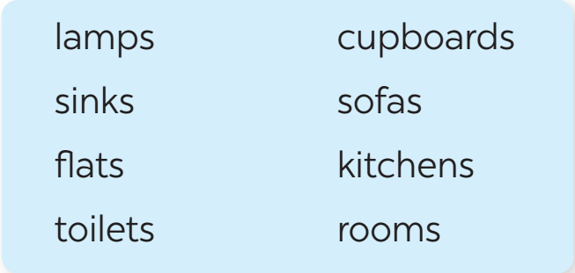  Suggested answers:  /s/: cats, lamps, books, months  /z/: beds, dogs, cans, rooms, videos, cookers, bees
Task 5: Listen to the conversation. Underline the final s in the words and put them into the correct column. (7 mins)
- Have students quickly read the conversation and underline the final “s” in the words.  - Now play the recording for students to listen to the conversation and write /s/ or /z/ under each “s” that they have underlined.  - Tell them to put the words with the final “s” in the correct column.  - Have them work in pairs to compare their answers. Check students’ answers. Ask them to explain their answers.  - Play the recording again for students to repeat each line of the conversation. Ask students to work in pairs to practise the conversation. - Call some pairs to practise the conversation. Comment on their pronunciation of the final “s”. | - Students work individually to underline the final “s” in the words.  - Students put those words in the correct columns.  - Students check their answers in pairs.  - Some pairs read aloud the conversation. | Answer key:  /s/: chopsticks, lamps  /z/: bowls, things, homes
e. Assessment
- Teacher’s observation and feedback on student’s pronunciation.

4. CONSOLIDATION (5 mins)
a. Wrap-up
- Teacher asks students to talk about what they have learnt in the lesson.
b. Homework
- Do exercises in the workbook.
- Find 5 more words with the sound /s/ and 5 more words with the sound /z/. Write them down and practise pronouncing the words.

Board Plan

Date of teaching …

Unit 2: My house
Lesson 2: A closer look 1

*Warm-up
Jumbled words and matching (Task 1)

* Vocabulary
1. hall (n)
2. chest of drawers (n)
3. sink (n)
4. dishwasher (n)
5. cupboard (n)

Task 2: Name the things.
Task 3: Ask and answer.

* Pronunciation
Task 4: Listen and repeat.
Task 5: Underline and put the words in column.

*Homework
UNIT 2: MY HOUSE
Lesson 3: A closer look 2

I. OBJECTIVES
By the end of this lesson, Ss will be able to:
1. Knowledge
- use the possessive case and prepositions of place
2. Competences
- Develop communication skills
- Be collaborative and supportive in pair work and teamwork
3. Personal qualities
- Love and proud of all family members
- Be responsible with the housework and take care of all family members
- Be responsible and hard-working
- Actively join in class activities

II. MATERIALS
- Grade 6 textbook, Unit 2, A closer look 2
- Computer connected to the Internet
- Projector / TV
- hoclieu.vn

Language analysis
The possessive case
Use | Example
We use ’s after a proper name.. | This is Elena’s room.
We use ’s after a singular noun | This is my mum’s book
Prepositions of place
Prepositions of place describe  where people or things are. | Example: in, on, behind, under, next to, in front of, between

Assumption
Anticipated difficulties | Solutions
Students may find it confusing when to use the grammar points. | Give short and clear explanations with legible examples for each case.

III. PROCEDURES
1. WARM-UP (5 mins)
a. Objectives:
- To activate students’ prior knowledge and vocabulary related to the targeted grammar of possessive case, preposition of place and to increase students' interest.
- To enhance students’ skills of cooperating with team mates.
b. Content:
- Memory game
c. Expected outcomes:
- Students can remember and answer teacher’s questions.
d. Organisation

TEACHER’S ACTIVITIES | STUDENTS’ ACTIVITIES | CONTENTS
Game: Memory game  - Teacher divides the class into 4 groups.  - Teacher tells students the rules of the game:  + Students have to study the picture of 3 people (Jack, Polly and Greg) and try to remember the things belonging to each person in 30 seconds without writing down in their notebooks.  + After 30 seconds, T shows the things of Jack, Polly and Greg and a member of each team has to answer quickly the question “Whose is it?”  + The group with more correct sentences will be the winner. | - Students work in 4 groups and follow the teacher's instruction to play the game. | 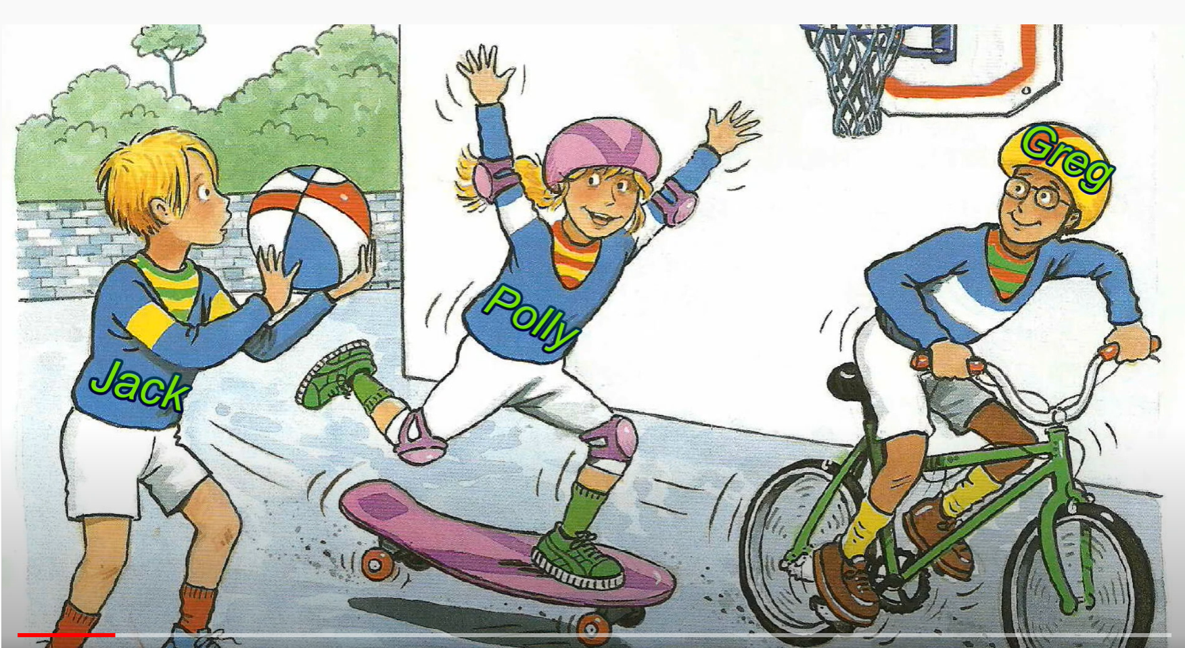  Questions and answers:  1. Whose jumper is it?  - It’s Polly’s jumper.  2. Whose T-shirt is it  - It’s Greg’s T-shirt.  3. Whose ball is it?  - It’s Jack’s ball.  4. Whose sock is it?  - It’s Jack’s sock.  5. Whose shoes is it?  - It’s Greg’s shoes.  6. Whose sock is it?  - It’s Polly’s sock.
e. Assessment
- Teacher corrects students’ answers (if needed).

2. ACTIVITY 1: PRESENTATION (10 mins)
a. Objectives:
- To have students get to know about the possessive case.
- To help Ss identify diﬀerent prepositions of place and use them correctly to describe where
people or things are.
b. Content:
- Introduce the possessive case and prepositions of place.
c. Expected outcomes:
- Students can identify the use of the possessive case and prepositions of place
d. Organisation

TEACHER’S ACTIVITIES | STUDENTS’ ACTIVITIES | CONTENTS
The possessive case
- Teacher draws students’ attention to the words in the answers from the Warm-up “Greg ‘s T- shirt, Jack’s ball, Polly’s sock” and asks them whether they know the meanings of these words.  - Teacher provides or confirms the answers and leads in the grammar focus of the lesson.  - Teacher writes the form of the possessive case on the board.  - Teacher ask students to read the Remember box carefully. | - Students answer teacher’s questions.  - Students read the Remember box carefully and listen to the teacher. | 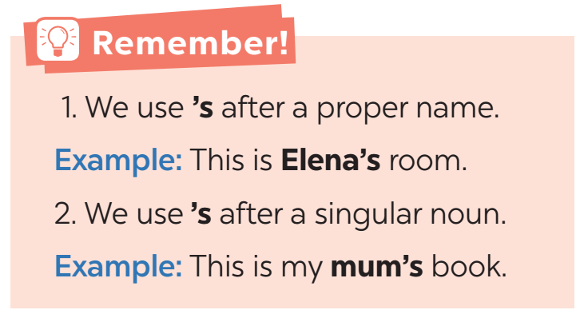
Prepositions of place
- Teacher asks students what prepositions of place they know. Encourage students to say as many as possible.  - Have them look at the Remember box to see if the prepositions they have mentioned are the same.  - Teacher confirms how to use prepositions of place. | - Students list as many prepositions as possible.  - Students read the Remember box and check their answers. | 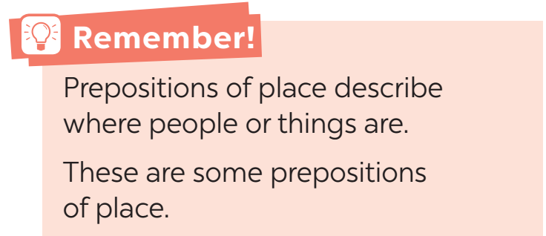
e. Assessment
- Teacher checks students’ understanding by asking some questions.

3. ACTIVITY 2: PRACTICE (25 mins)
a. Objectives:
- To help Ss practise the possessive case and prepositions of place
b. Content:
- Task 1: Choose the correct answer.
- Task 2: Complete the sentences with the correct possessive forms.
- Task 3: Write the correct preposition in the box under each picture. Say a sentence to describe the picture.
- Task 4: Look at the picture and write T (True) or F (False) for each sentence. Correct the false ones.
c. Expected outcomes:
- Students can use the correct possessive forms to complete the sentences.
d. Organisation

TEACHER’S ACTIVITIES | STUDENTS’ ACTIVITIES | CONTENTS
Task 1: Choose the correct answer. (3 mins)
- Teacher asks students to do the exercise individually and then compare their answers with a classmate.  - Check the answers as a class.  - Teacher confirms the correct answers. | - Students do the task individually and then check the answers with a partner before checking as a class. | Answer key:  1. grandmother’s  2. sister’s  3. cousin’s  4. Nam’s  5. An’s
Task 2: Complete the sentences with the correct possessive forms. (4 mins)
- Teacher has students do this exercise individually and calls on two students to write their answers on the board.  - Teacher draws all students’ attention to the board and checks the answers together.  - Teacher confirms the correct answers. | - Students do the task individually.  - Two students write their answers on the board.  - Check the answer as a class. | Answer key:  1. Mi’s  2. teacher’s  3. Nick’s  4. father’s  5. brother’s
Task 3: Write the correct preposition in the box under each picture. Say a sentence to describe the picture. (6 mins)
- Teacher has students do this exercise 3 in pairs, then asks for students’ answers and confirms the correct answers.  - Teacher has students work in pairs to say sentences describing the pictures. Move around to offer help if needed.  - Teacher calls on some students to say their sentences. If there is time, ask some students to write their sentences on the board. | - Students work in pairs to do the task. | Answer key:  2. next to  3. behind  4. in  5. in front of  6. between  7. under  2. The dog is next to the armchair.  3. The cat is behind the TV.  4. The cat is in the wardrobe.  5. The dog is in front of the doghouse.  6. The cat is between the lamp and the armchair.  7. The cat is under the table.
Task 4: Look at the picture and write T (True) or F (False) for each sentence. Correct the false ones. (7 mins)
- Teacher has students look at the picture of the room and asks them to describe the room briefly, then has them read each sentence, look at the picture and decide if each sentence is true or false. If it is false, ask them to correct it.  - Teacher has students do this exercise individually before they share their answers with a partner. Ask some students to read out their answers.  - Teacher confirms the correct ones. | - Students follow the teacher’s instructions and then do the task individually.  - Share the answers with a partner.  - Some students read out their answers. | Answer key:  1. T  2. F (The school bag is under the table.)  3. F (The clock is between the two pictures.)  4. T  5. F (The cap is on the pillow.)
e. Assessment
- Teacher corrects the students as a whole class.

4. ACTIVITY 3: PRODUCTION (10 mins)
a. Objectives:
- To help Ss practise asking and answering about the position of things
b. Content:
- Task 5: Game: Memory challenge.
c. Expected outcomes:
- Students can use the target grammar to ask and answers questions about the position of things
d. Organisation

TEACHER’S ACTIVITIES | STUDENTS’ ACTIVITIES | CONTENTS
Task 5: Game: Memory challenge.
Work in pairs. Look at the picture in 4 carefully, and then cover it. Ask and answer questions about the position of things in the picture.
- Teacher has students work in pairs to play the game Memory challenge.  - Students look at the picture in Exercise 4 for 30 seconds and then cover it.  - They ask and answer questions about the position of the things in the picture.  - Teacher invites some pairs to perform in front of the class. | - Students work in pairs and follow the teacher’s instruction to play the game. | Example:  A: Where are the books?  B: They’re on the table.
e. Assessment
- Teacher corrects the students as a whole class.

4. CONSOLIDATION (4 mins)
a. Wrap-up
- Summarise the main points of the lesson.
b. Homework
- Do exercises in the Workbook.

Board Plan

Date of teaching
Unit 2: My house
Lesson 3: A closer look 2
* Warm-up
Game: Memory game

I. Grammar
1. The possessive case
2. Prepositions of place

II. Practice
Task 1: Choose the correct answer.
Task 2: Complete the sentences.
Task 3: Write the correct preposition.
Task 4: Decide True or False.
Task 5: Game: Memory challenge.

* Homework

UNIT 2: MY HOUSE
Lesson 4: Communication

I. OBJECTIVES
By the end of this lesson, Ss will be able to:
1. Knowledge
- Know how to give suggestions
2. Competences
- Develop communication skills and creativity
- Be collaborative and supportive in pair work and teamwork
3. Personal qualities
- Love and proud of all family members
- Be responsible with the housework and take care of all family members
- Be responsible and hard-working
- Actively join in class activities

II. MATERIALS
- Grade 6 textbook, Unit 2, Communication
- Computer connected to the Internet
- Projector / TV
- hoclieu.vn

Assumption
Anticipated difficulties | Solutions
Students may lack knowledge about the topic. | Provide students with information about the knowledge they do not know.
Students may have underdeveloped reading, speaking and co-operating skills. | - Encourage students to work in pairs, in groups so that they can help each other.  - Provide feedback and help if necessary.
Some students will excessively talk in the class. | - Define expectation in explicit detail.  - Have excessively talkative students practise.  - Continue to define expectations in small chunks (before every activity).

III. PROCEDURES
1. WARM-UP (5 mins)
a. Objectives:
- To introduce the topic.
- To enhance students’ skills of cooperating with team mates.
b. Content:
- Pictures describing
c. Expected outcomes:
- Students can use the learned vocabulary and grammar point to speak
d. Organisation
TEACHER’S ACTIVITIES | STUDENTS’ ACTIVITIES | CONTENTS
Pictures describing  - Teacher shows the picture of Nam’s house and asks students to describe as many things in the picture as possible.  - Teacher checks the answers.  - Teacher leads students into the lesson by telling what they are going to learn: “We are going to learn how to give suggestions and practice describing a house”. | - Students give their answers. | Suggested answers:  - This is Nam’s house.  - There are 4 rooms in his house.  - In the living room, there is a lamp, a picture, a table and a sofa.  - In the kitchen, there is a fridge, a dishwasher and a sink.  …
e. Assessment
- Teacher corrects students (if needed).

2. ACTIVITY 1: EVERYDAY ENGLISH (15 mins)
a. Objectives:
- To introduce the structure of giving suggestions.
- To help Ss practise giving suggestions.
b. Content:
- Task 1: Elena and her mum are discussing how to decorate her bedroom. Listen and read the
dialogue. Pay attention to the highlighted sentences.
- Task 2: Work in pairs. Make a similar dialogue. Remember to use the structures.
c. Expected outcomes:
- Students can use the structures to give suggestions.
d. Organisation
TEACHER’S ACTIVITIES | STUDENTS’ ACTIVITIES | CONTENTS
Task 1: Elena and her mum are discussing how to decorate her bedroom. Listen and read the
dialogue. Pay attention to the highlighted sentences. (7 mins)
- Teacher plays the recording for students to listen and read the dialogue between Elena and her mum at the same time.  - Teacher asks students to pay attention to the highlighted sentences.  - Teacher elicits the structures to give suggestions from students.  - Teacher has students practise the dialogue in pairs. Call some pairs to practise the dialogue in front of the class. | - Students listen to the recording and pay attention to the highlighted sentences.  - Students give their ideas regarding the structures  - Students practise the dialogue in pairs. | 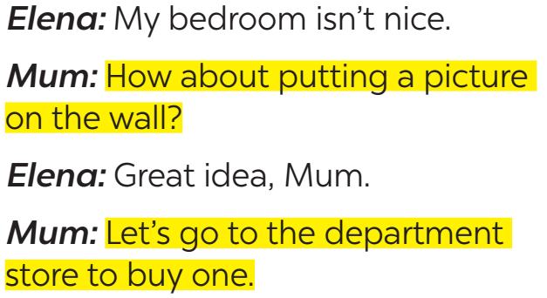
Task 2: Work in pairs. Make a similar dialogue. Remember to use the structures. (8 mins)
- Teacher give students some situations to practise:  Situation 1: You want to buy some furniture for their homes.  Situation 2: You want to do some activities at the weekend with your friend.  Situation 3: You want to buy some new school things  - Teacher asks students to work in pairs.  - Teacher moves around to observe and provide help.  - Teacher calls some pairs to practise in front of the class, then comments on their performance. | - Students work in pairs and take turns practise giving suggestions | Structure:  - How about + V-ing?  - Let’s + V.  Suggested answers:  A: I am so bored.  B: How about going to the cinema this weekend?  A: Great idea!
e. Assessment
- Teacher checks students’ understanding by asking some checking-questions.

3. ACTIVITY 2: ﻿LIVING PLACES (20 mins)
a. Objectives:
- To help Ss practise asking and answering questions about the diﬀerences between two houses.
- To help Ss practise describing their house.
b. Content:
- Task 3: Mi tells Nick about her grandparents’ country house. Look at the pictures of her
grandparents’ house and complete the sentences.
- Task 4: Student a looks at the pictures of Nick’s house on this page. Student B looks at the pictures of Mi’s house on page 25. Ask questions to find the diﬀerences between the two houses.
- Task 5: Draw a simple picture of your house. Tell your partner about it.
c. Expected outcomes:
- Students can identify different types of houses.
- Students can ask and answer questions about houses.
d. Organisation
TEACHER’S ACTIVITIES | STUDENTS’ ACTIVITIES | CONTENTS
Task 3: Mi tells Nick about her grandparents’ country house. Look at the pictures of her
grandparents’ house and complete the sentences. (5 mins)
- Teacher has students look at the picture and try describing Mi’s grandparents’ country house.  - Teacher encourage students to say full sentences.  - Then ask students to work in pairs to complete the given sentences.  - Teacher moves around to observe and provide help.  - After that, T invites students to share their answers.  - Teacher confirms the correct answers. | - Students describe the house in the picture.  - Students work in pairs to complete the sentences. | Answer key:  1. country  2. are  3. is  4. chairs  5. on
Task 4: Student a looks at the pictures of Nick’s house on this page. Student B looks at the pictures of Mi’s house on page 25. Ask questions to find the diﬀerences between the two houses. (7 mins)
- Teacher models with a student.  - Teacher asks students in each pair not to look at each other’s picture and make similar conversations.  - Teacher reminds students to note down the differences between the two houses.  - After some minutes, the pair which has the most differences will be the winner. Ask some pairs to act out the conversation. Other pairs listen and add more differences if there are any. | - Students work in pairs to ask and answer to find out the differences between 2 houses.  - Some pairs act out the conversation. | 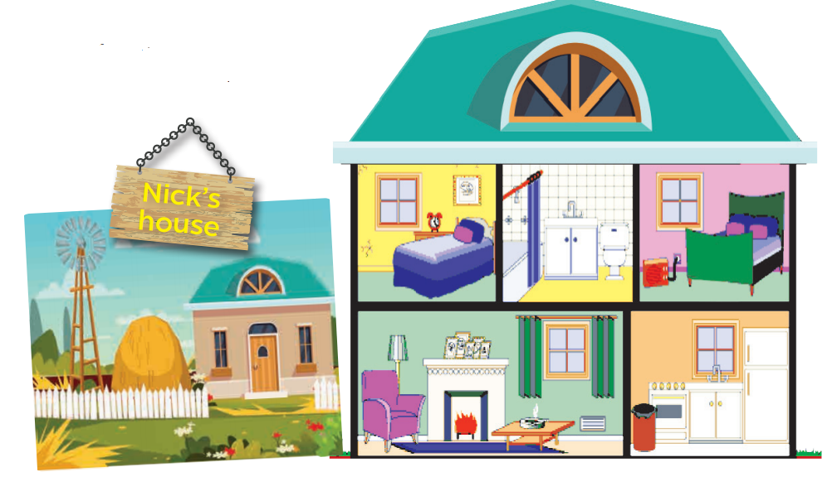  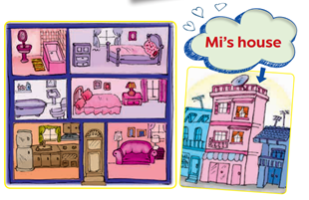  Suggested conversation:  T: Nick lives in a country house. Where does Mi live?  S: She lives in a town house.  T: How many rooms are there in Mi’ house?  S: There are six rooms. What about in Nick’s house?  T: …
Task 5: Draw a simple picture of your house. Tell your partner about it. (8 mins)
- Teacher gives students 5 – 7 minutes to draw a simple picture of their house, then asks students to work in pairs to tell each other about their house. If time allows, teacher can ask them to note down the differences between their houses.  - Teacher calls some students to describe their friend’s house to the class. Other students and teacher listen and give comments. | - Students draw a simple picture of their house then work in pairs to talk about the house.  - Students may also present the differences between their house and their friend’s if time allows.
e. Assessment
- Teacher goes around and corrects students while they’re practising.

4. CONSOLIDATION (3 mins)
a. Wrap-up
- Have Ss say what they have learnt in the lesson.
b. Homework
- Do exercises in the workbook.
- Prepare for the next lesson: Skills 1

Board Plan

Date of teaching
Unit 2: My house
Lesson 4: Communication
*Warm-up
Pictures describing

* Everyday English
Giving suggestions
+ How about + V-ing?
+ Let’s + V
Task 1: ﻿Listen and read.
Task 2: ﻿ Make similar dialogues.

* Living places
Task 3: Look and complete.
Task 4: ﻿Ask and answer.
Task 5: ﻿Draw and tell.

*Homework

UNIT 2: MY HOUSE
Lesson 5: Skills 1

I. OBJECTIVES
By the end of this lesson, Ss will be able to:
1. Knowledge
- Read for general and specific information about a room at the Crazy House Hotel in Da Lat
- Describe houses, rooms and furniture
2. Competences
- Develop communication skills and creativity
- Be collaborative and supportive in pair work and teamwork
- Develop presentation skill
3. Personal qualities
- Love and proud of all family members
- Be responsible with the housework and take care of all family members
- Be responsible and hard-working
- Actively join in class activities

II. MATERIALS
- Grade 6 textbook, Unit 2, Skills 1
- Computer connected to the Internet
- Projector / TV
- hoclieu.vn

Language analysis
Form | Pronunciation | Meaning | Vietnamese equivalent
1. strange (adj) | /streɪndʒ/ | unusual and unexpected, or difficult to understand | lạ
2. wardrobe (n) | /ˈwɔːdrəʊb/ | a tall cupboard in which you hang your clothes | tủ quần áo

Assumption
Anticipated difficulties | Solutions
1. Students may lack knowledge about some lexical items. | Provide students with the meaning and  pronunciation of words.
2. Students may have underdeveloped reading, speaking and co-operating skills. | - Let students read the text again (if needed).  - Create a comfortable and encouraging environment for students to speak.  - Encourage students to work in pairs, in groups so that they can help each other.  - Provide feedback and help if necessary.
3. Some students will excessively talk in the class. | - Define expectation in explicit detail.  - Have students talking excessively practise.  - Continue to define expectations in small chunks (before every activity).

III. PROCEDURES
1. WARM-UP (5 mins)
a. Objectives:
- To create an active atmosphere in the class before the lesson;
- To lead into the new lesson.
b. Content:
- Game: Shark attack
c. Expected outcomes:
- Students can guess the word
d. Organisation
TEACHER’S ACTIVITIES | STUDENTS’ ACTIVITIES | CONTENTS
Shark attack  - Teacher divides the class into 2 teams.  - Then, teacher lets students play “Shark attack” to find the hidden word: C R A Z Y  - If one team guesses the wrong letter, the other team will get the chance.  - The team which finds the word first will be the winner. | - Students work in 2 teams to play the game. | 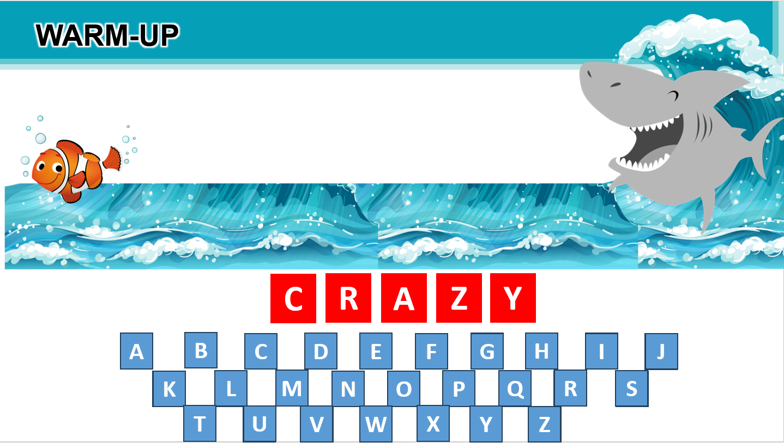
e. Assessment
- Teacher corrects students’ answers (if needed).

2. ACTIVITY 1: READING (20 mins)
a. Objectives:
- To help Ss learn new vocabulary in the reading text.
- To improve Ss’ skill of reading for general ideas and for details (scanning).
b. Content:
- Task 1: Look at the text. Answer the questions.
- Vocabulary pre-teaching
- Task 2: Read the text again and answer the questions.
- Task 3: Circle the things in the Tiger Room.
c. Expected outcomes:
- Students can identify the meaning and uses of new words and how to use the target vocabulary.
d. Organisation
TEACHER’S ACTIVITIES | STUDENTS’ ACTIVITIES | CONTENTS
Task 1: Look at the text. Answer the questions. (6 mins)
Reading skill: Predicting  - Teacher asks students to read the “Reading skill” box and explains any words that students do not know.  - Teacher tells students that predicting is an important reading skill that can help them have a general understanding of the text.  - Teacher tells students to quickly look at the text, the pictures and answer the questions.  - Teacher asks for students’ answers.  - Then teacher tells them to read the text quickly to check their prediction. | - Students read the Reading skill box carefully.  - Students quickly read the questions, the text and the pictures, then answer. | Questions:  1. Is it an email or a letter?  2. What is the text about?  Answer key:  1. It’s an email.  2. The text is about Nick’s room at the Crazy House Hotel.
Vocabulary pre-teaching (3 mins)
- Teacher introduces the vocabulary by:  + Providing the synonym or antonym of the words.  + Providing the pictures of the words.  + Providing the definition of the words | - Students write down the new words. | New words:  1. strange (adj) [explanation]  2. wardrobe (n) [visual]
Task 2: Read the text again and answer the questions. (7 mins)
- Teacher lets students look at task 2 and tells them how to do this kind of exercise:  + Read the questions.  + Underline the keywords.  + Locate the keywords in the text.  + Read that part and answering the  questions.  - Teacher has students read the text in detail to answer the questions and tells them to underline parts of the email that help them with the answers.  - Teacher tells them to compare their answers in pairs before giving the answers to the teacher.  - Teacher asks them to give evidence when giving the answers. | - Students read the text again to do the task.  - Find evidences for the answers in the text.  - Compare the answer with a partner before checking as a class. | Answer key:  1. He’s in Da Lat with his parents.  2. There are ten rooms.  3. Because there’s a big tiger on the wall.  4. It’s under the bed.
Task 3: Circle the things in the Tiger Room. (4 mins)
- Teacher asks students to read through the words given and then locate them in the text. If they find a similar word in the text, they should circle it in the list.  - Teacher has students compare their answers.  - Teacher checks and confirms the correct answers. | - Students do the task individually.  - Compare the answer with a partner before checking as a class. | Answer key:  a window  a lamp  a wardrobe  a desk
e. Assessment
- Teacher checks students’ understanding with follow up questions.

3. ACTIVITY 2: SPEAKING (15 mins)
a. Objectives:
- To provide an opportunity for Ss to practise describing the hotel room they have designed.
b. Content:
- Task 4: Create a new room for the hotel. Draw a plan for the room.
- Task 5: Show your plan to your partner and describe it.
c. Expected outcomes:
- Students can describe the room they have designed.
d. Organisation
TEACHER’S ACTIVITIES | STUDENTS’ ACTIVITIES | CONTENTS
Task 4: Create a new room for the hotel. Draw a plan for the room. (7 mins)
- Teacher tells each student to create a new room for the hotel and draw a plan for the room.  - Teacher sets a time limit for students to do it.  - Teacher asks students to give the room a name and bear in mind the organisation of the room including the things in the room and their position.  - Have them note down these ideas quickly. | - Students create a new room for the hotel and quickly note down the ideas for planning the room. | 
Task 5: Show your plan to your partner and describe it. (8 mins)
- Have students work in pairs and show the plan to their partner. Ask students to take turns to describe their rooms.  - Remind them to focus on the three points on the board. Move around to observe and offer help.  - Call on some students to show their plan to the whole class and describe it. Other students and the teacher listen and vote for the best plan.  - Have students give comments on their friends’ and vote for the most interesting and informative presentation.  - Teacher gives feedback and comments. | - Students work in pairs to show their plan to the partner.  - Some students show their plan to the class, other students listen and give comments. | Example:  This is the shark room. There’s a big shark at the door. There’s a table and a sofa in the middle of the room ...
e. Assessment
- Teacher gives corrections and feedback.

4. CONSOLIDATION (5 mins)
a. Wrap-up
- Summarise the main points of the lesson.
b. Homework
- Do exercises in the workbook.

Board Plan

Date of teaching
Unit 2: My house
Lesson 5: Skills 1
*Warm-up
Game: …

* Reading
Reading skills: Predicting
Task 1: Answer the questions.
Vocabulary
1. strange (adj)
2. wardrobe (n)
Task 2: Read and answer.
Task 3: Circle.

* Speaking
Task 4: Create a new room.
Task 5: Describe your plan.

*Homework

UNIT 2: MY HOUSE
Lesson 6: Skills 2

I. OBJECTIVES
By the end of this lesson, Ss will be able to:
1. Knowledge
- Listen to get information about rooms and houses
- Write an email to a friend to share where you live
2. Competences
- Develop communication skills and creativity
- Be collaborative and supportive in pair work and teamwork
3. Personal qualities
- Love and proud of all family members
- Be responsible with the housework and take care of all family members
- Be responsible and hard-working

II. MATERIALS
- Grade 6 textbook, Unit 2, Skills 2
- Computer connected to the Internet
- Projector / TV
- hoclieu.vn

Assumption
Anticipated difficulties | Solutions
1. Students may have  underdeveloped listening skills. | - Play the recording many times if necessary.  - Encourage students to work in pairs, in groups so that they can help each other.  - Provide feedback and help if necessary.
2. Students may have underdeveloped listening, writing and co-operating skills. | - Play the recording many times if necessary.  - Encourage students to work in pairs, in groups so that they can help each other.  - Provide feedback and help if necessary.
2. Some students will excessively talk in the class. | - Define expectation in explicit detail.  - Have excessively talkative students practise.  - Continue to define expectations in small chunks (before every activity).

III. PROCEDURES
1. WARM-UP (10 mins)
a. Objectives:
- To create an active atmosphere in the class before the lesson;
- To lead into the new lesson.
b. Content:
- Game: Lucky number
c. Expected outcomes:
- Students can answer the questions related to rooms and houses.
d. Organisation
TEACHER’S ACTIVITIES | STUDENTS’ ACTIVITIES | CONTENTS
- Teacher divides the class into 2 teams.  - Teacher allows students 30 seconds to read through the email again.  - Each team chooses the number they like, then tries to answer the question correctly.  - The team which chooses a lucky number will get two points  without answering any questions.  - The team which has more points will be the winner.  - Teacher introduces students the content of the lesson today: “In the previous lesson, you already read about Nick’s room at the Crazy House Hotel. In the listening lesson  today, we are going to listen to Mai talking about her house.” | - Students work in 2 teams, quickly read the email again and try to remember the information.  - Play the Lucky numbers game in teams. | Questions:  1. What is the name of the room where Nick is staying? (Tiger)  2. How many rooms are there in the hotel? (10)  3. Is there a wardrobe in Nick’s room? (Yes)  4. Where is that Crazy House Hotel? (In Da Lat)  5. Are the rooms named after different flowers? (No)  6. Lucky number  7. Where is the bed in Nick’s room? (Under the window)  8. Why is the room called the Tiger room? (Because there’s a big tiger on the wall).  9. Who is Nick staying with? (With his parents)  10. Lucky number.
e. Assessment
- Teacher corrects for students (if needed)

2. ACTIVITY 1: LISTENING (15 mins)
a. Objectives:
- To help students brainstorm and have an overview about what they are going to listen to
- To help Ss develop their skill of listening for specific information about a house
b. Content:
- Task 1: Look at the pictures. Name each of them. Guess if they are mentioned in the listening text. Listen and check your guesses.
- Task 2: Listen to Mai talking about her house. Tick T (True) or F (False).
c. Expected outcomes:
- Students can understand the listening and get ideas to answer the questions.
d. Organisation
TEACHER’S ACTIVITIES | STUDENTS’ ACTIVITIES | CONTENTS
Task 1: Look at the pictures. Name each of them. Guess if they are mentioned in the listening text. Listen and check your guesses.
- Ask students to look at the pieces of furniture and parts of the house and name them.  - Call on some students to say the words out loud.  - Ask some students to write the words on the board.  - Have students guess if these things are mentioned in the listening text. If they say yes for a thing, put a tick next to the word.  - Play the recording once for students to check their guesses. | - Students look at the pictures, name the things and guess if they are mentioned in the listening text.  - Students listen to the recording. | Answer key:  1. bookshelf  2. sofa  3. desk  4. clock  5. window  Things mentioned in the listening text: bookshelf, desk, clock, window
Task 2: Listen to Mai talking about her house. Tick T (True) or F (False).
- Have students look at the sentences in this activity. Ask them how to do it. Give them some strategies to do the exercise (e.g. reading the sentences, underlining the key words, listening to the text paying attention to the key words, deciding if each sentence is true or false).  - Play the recording twice. For a better class, ask students to take notes of the information to explain why a sentence is false.  - Have students share their answers in pairs. Invite some pairs to give their answers and confirm the correct ones.  - Play the recording again if needed, stop at the place where students find it difficult to hear.  - For a better class, ask students to correct the false sentences. | - Students listen to the teacher’s strategies and then listen to the recording to do the task.  - Share their answers and listen again to check. | Answer key:  1. F (There are three people.)  2. F (There are six rooms.)  3. T  4. T  5. F (She often reads books in her bedroom.)
e. Assessment
- Teacher checks students’ answers as a whole class.

3. ACTIVITY 2: WRITING (15 mins)
a. Objectives:
- To help Ss practise writing an email about their houses
b. Content:
- Task 3: ﻿Answer the questions.
- Task 4: Write an email to Mira, your penfriend. Tell her about your house. Use the answers to the questions in 3.
c. Expected outcomes:
- Students can use learned vocabulary and grammar to write an email about their houses
d. Organisation
TEACHER’S ACTIVITIES | STUDENTS’ ACTIVITIES | CONTENTS
Task 3: ﻿ Answer the questions.
- Show a sample email and ask students some questions (e.g. How many parts are there in an email to your friend? What are they? What should you include when writing each part?).  - Tell students that now they are going to focus on the body of the email only.  - Tell them that answering the guiding questions is one way to help them brainstorm as well as organise ideas for their writing.  - Have students answer the questions  individually, encouraging them to write the answers in full sentences.  - Move around to offer help.  - Invite some students to share their answers to the class. Comment on their answers. | - Students read the sample email carefully and listen to the teacher’s guide.  - Students answer the questions individually. | 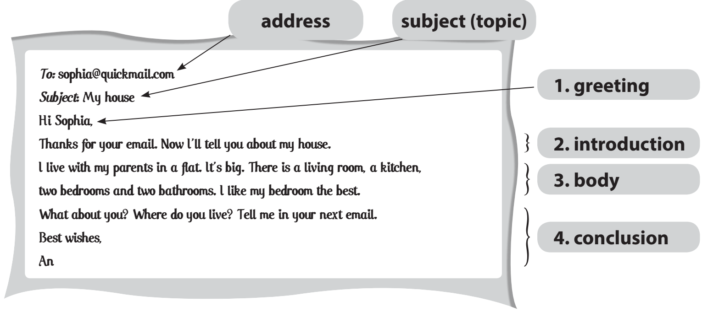
Task 4: Write an email to Mira, your penfriend. Tell her about your house. Use the answers to the questions in 3.
- Ask students to write the body of their email individually. Ask one or two students to write their email on the board.  - Other students and teacher comment on the emails on the board. - Teacher asks students to exchange their notebooks to check their friends’ writing.  - Teacher then gives feedback as a class discussion. | - Students listen to the teacher to know how to write and email.  - Students write the body of the email individually.  - Some students write on the board, others exchange their notebooks. | How to write an email to a friend:  1. In the subject line, write brieﬂy what the email is about.  2. Begin the email with a greeting (Dear / Hi / Hello).  3. The introduction is the first paragraph. Ask about his / her health, thank him / her for the  previous email or write the reasons for the email, etc.  4. In the body, write about the subject(s) of the email. Write each subject in a new paragraph.  5. The conclusion is the last paragraph. Say goodbye, ask your friend to write back, etc.
e. Assessment
- Teacher gives corrections and feedback.

4. CONSOLIDATION (2 mins)
a. Wrap-up
- Summarise the main points of the lesson.
b. Homework
- Rewrite the email in the notebook.
- Do exercises in the workbook.

Board Plan

Date of teaching
Unit 2: My house
Lesson 6: Skills 2
*Warm-up
Game: Lucky number
*Listening
Task 1: Name the pieces of furniture.
Task 2: ﻿Listen and tick T or F.
﻿
*Writing
Task 3: ﻿Answer the questions.
Task 4: Write an email.

*Homework

UNIT 2: MY HOUSE
Lesson 7: Looking back and Project

I. OBJECTIVES
By the end of this lesson, Ss will be able to:
1. Knowledge
- Review the vocabulary and grammar of Unit 2
- Apply what they have learnt (vocabulary and grammar) into practice through a project.
2. Competences
- Develop communication skills and creativity
- Develop presentation skill
- Be collaborative and supportive in pair work and teamwork
3. Personal qualities
- Love and proud of all family members
- Be responsible with the housework and take care of all family members
- Be responsible and hard-working
- Actively join in class activities

II. MATERIALS
- Grade 6 textbook, Unit 2, Looking back and Project
- Computer connected to the Internet
- Projector / TV
- hoclieu.vn

Assumption
Anticipated difficulties | Solutions
Students may have underdeveloped speaking, writing and co-operating skills when doing the project. | - Encourage students to work in pairs, in groups so that they can help each other.  - Provide feedback and help if necessary.
Some students will excessively talk in the class. | - Define expectation in explicit detail.  - Have excessively talkative students practise.  - Continue to define expectations in small chunks (before every activity).

III. PROCEDURES
1. WARM-UP (6 mins)
a. Objectives:
- To create an active atmosphere in the class before the lesson
- To help Ss review the vocabulary of Unit 2
b. Content:
- Categorising (Task 1)
c. Expected outcomes:
- Students can use the knowledge they have learnt in this unit to complete the activity.
d. Organisation

TEACHER’S ACTIVITIES | STUDENTS’ ACTIVITIES | CONTENTS
Categorising (Task 1)  - Teacher divides the class into 3 big teams.  - Each team will be assigned a name.  - Teacher asks students to categorise all words into the correct groups.  - The group having the most suitable and correct answers is the winner. | - Students work in 3 teams to categorise all the words.  - Students add more words to each groups | Suggested answers:  - Types of house: flat, town house, country house, stilt house, villa, cottage, farmhouse, bungalow, …  - Rooms: hall, living room, bedroom, bathroom, kitchen, dining room, guest room, utility room, …  - Furniture: chest of drawers, sink, fridge, dishwasher, cupboard, microwave, air conditioner, stool, armchair,…
e. Assessment
- Teacher corrects for students (if needed)

2. ACTIVITY 1: LOOKING BACK (16 mins)
a. Objectives:
- To help Ss revise the possessive case and prepositions of place.
b. Content:
- Task 2: Complete the second sentence with the correct possessive form.
- Task 3: Make sentences. Use prepositions of place.
- Task 4: Write three sentences to describe your favourite room in your house. Write the sentences in your notebook.
c. Expected outcomes:
- Recall the uses of the possessive case and prepositions of place
d. Organisation
TEACHER’S ACTIVITIES | STUDENTS’ ACTIVITIES | CONTENTS
Task 2: Complete the second sentence with the correct possessive form.
- Have students say how to form the possessive form with proper names and singular nouns.  - Ask students to do the exercise  individually and then exchange their answers with a classmate.  - Call on some students to write their answers on the board. Other students give comments.  - Confirm the correct answers. | - Students do the task individually.  - Exchange the answers with a partner and check the correct answers. | Answer key:  1. teacher’s  2. brother’s  3. Elena’s  4. grandfather’s  5. Vy’s
Task 3: Make sentences. Use prepositions of place.
- Ask students to say the prepositions of place they have learnt.  - Have students look at the pictures and do this exercise individually. Ask some students to write the sentences on the board.  - Check students’ answers. | - Students do the task individually.  - Some students write their answers on the board. | Answer key:  1. The cat is on the table.  2. The dog is in front of the doghouse.  3. The cat is between the bookshelf and the sofa.  4. The cat is behind the computer.  5. The girl is on the sofa.  6. The boy is next to the sofa.
Task 4: Write three sentences to describe your favourite room in your house. Write the sentences in your notebook.
- Ask one student what room in the house is his / her favourite.  - Encourage him / her to say one or two sentences about it.  - Have students write three sentences to describe their favourite room.  - Remind students to use prepositions of place.  - Students share their sentences with their partners.  - Some students are asked to write their sentences on the board.  Teacher and other students give  feedback. | - Students answer teacher’s questions about his / her favourite room.  - Students write 3 sentences to describe their favourite room.  - Share the answer with their partners. | Example:  There’s a big bed next to the door.  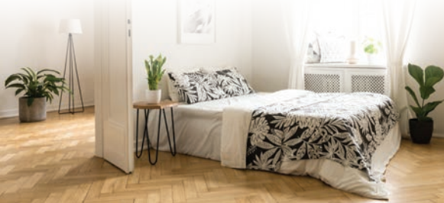
e. Assessment
- Teacher corrects students as a whole class.

3. ACTIVITY 3: PROJECT (17 mins)
a. Objectives:
- To help Ss improve their creativity and teamwork
- To improve their speaking and presentation skills
b. Content:
- Poster presentation.
c. Expected outcomes:
- Students can present their posters about their own drawing of strange houses.
d. Organisation
TEACHER’S ACTIVITIES | STUDENTS’ ACTIVITIES | CONTENTS
Strange house  - Ask Ss to read the instructions again (T has already assigned the project since the first lesson of the Unit and checked their progress after each lesson). Let students have some time to check their posters for the final time and make any adjustments if necessary.  - T has groups show their posters and present to the class.  - Give feedback to students’ presentations. | - Students work in groups to finalise their posters and then present to the class. | 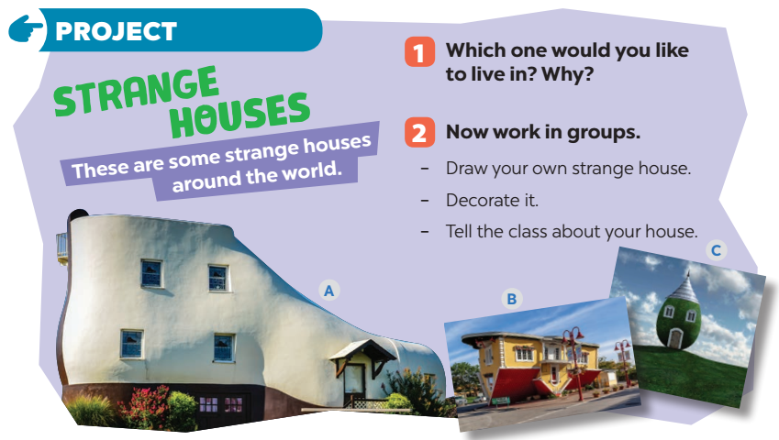
e. Assessment
- Teacher gives corrections and feedback.

4. CONSOLIDATION (4 mins)
a. Wrap-up
- Summarise the main points of the lesson.
b. Homework
- Prepare for the next lesson
Board Plan

Date of teaching
Unit 2: My house
Lesson 7: Looking back and Project
*Warm-up
Brainstorming (Task 1)

*Vocabulary
﻿
*Grammar
﻿Task 2: Complete the second sentence.
Task 3: Make sentences.
Task 4: Write three sentences about your favourite room.

*Project
Strange house

* Homework

